Chapter.2 DESIGN OF DC MACHINES

Details to be specified while ordering a DC machine or consumer’s specification

- Output : kW (for generators), kW or Hp (for motors)
- Voltage : V volt
- Speed : N rpm
- Rating : Continuous or Short time
- Temperature rise: θ0C for an ambient temperature of 400C
- Cooling : Natural or forced cooling
- Type: Generator or motor, separately excited or self-excited-shunt, series, or compound, if compound type of connection – long or short shunt, type of compounding – cumulative or differential, degree of compounding – over, under or level. With or without inter poles, with or without compensating windings,with or without equalizer rings in case of lap winding.
- Voltage regulation ( in case of generators) : Range and method
- Speed control ( in case of motors ) : range and method of control
- Efficiency: must be as for as possible high (As the efficiency increases, cost of the machine also increases).
- Type of enclosure: based on the field of application – totally enclosed, screen protected, drip proof, flame proof, etc.,
- Size of the machine etc.,

Size of the DC machine
The size of the DC machine depends on the main or leading dimensions of the machine viz., diameter of the armature D and armature core length L. As the output increases, the main dimensions of the machine D and L also increases.
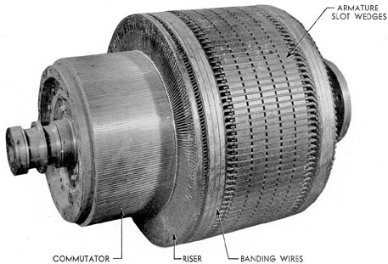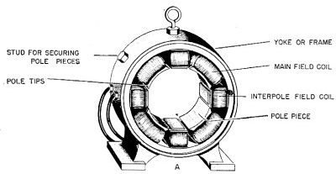
L
D

Figure.1.Armature of a dc machine Figure.2. Yoke and pole arrangement of a dc machine

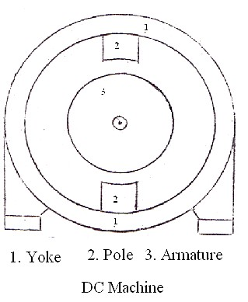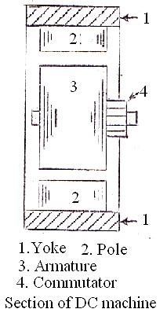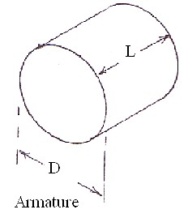

OUTPUT EQUATION

Note: Output equation relates the output and main dimensions of the machine. Actually it relates the power developed in the armature and main dimensions.

Derivation:
Nomenclature:

E : emf induced or back emf Ia : armature current
φ : Average value of flux / pole
Z : Total number of armature conductors N : Speed in rpm
P : Number of poles
A : number of armature paths or circuits D : Diameter of the armature
L : Length of the armature core

Power developed in the armature in kW = E Ia x 10-3

= φ Z N P
60 A
- Ia
× 10-3

I Z N x 10-3

= (Pφ ) ×
a ×
....... (1)

A 60
The term Pφ represents the total flux and is called the magnetic loading. Magnetic loading/unit area of the armature surface is called the specific magnetic loading or average value of the flux density in the air gap Bav. That is,

Bav
= Pφ
π DL
Wb/m2
or tesle
denoted
by T

Therefore Pφ
= Bav π DL ................ (2)

The term
(Ia Z/A)
represents the total ampere-conductors on the armature and is called the

electric loading. Electric loading/unit length of armature periphery is called the specific electric loading q. That is,

q = Ia Z
ampere - conductors / m

A π D
Therefore Ia
Z/A = q π D ............ (3)

Substitution of equations 2 and 3 in 1, leads to

kW =
Bav π DL ×
q π D ×
N × 10-3
60

= 1.64 ×
B q D2 L N

= C0 D L N
av
2

where C0
is called the output coefficeint of the DC machine and is

equal to 1.64 x 10-4 B q.
av

Therefore D2 L =
kW m3

1.64 × 10-4 B q N
av

The above equation is called the output equation. The D2L product represents the size of the machine or volume of iron used. In order that the maximum output is obtained/kg of iron used, D2L product must be as less as possible. For this, the values of q and Bav must be high.

Effect of higher value of q

Note: Since armature current Ia and number of parallel paths A are constants and armature diameter D must be as less as possible or D must be a fixed minimum value, the number of

armature conductors increases as
q = Ia Z / A π D
increases.

    - As q increases, number of conductors increases, resistance increases, I2R loss increases and therefore the temperature of the machine increases. Temperature is a limiting factor of any equipment or machine.
    - As q increases, number of conductors increases,conductors/slot increases, quantity of insulation in the slot increases, heat dissipation reduces, temperature increases, losses increases and efficiency of the machine reduces.
    - As q increases, number of conductors increases, armature ampere-turns per pole ATa / pole = (Ia Z / 2 A P) increases, flux produced by the armature increases, and therefore the effect of armature reaction increases. In order to overcome the effect of

armature reaction, field mmf has to be increased. This calls for additional copper and increases the cost and size of the machine.
    - As q increases, number of conductors and turns increases, reactance voltage proportional to (turns)2 increases. This leads to sparking commutation.

Effect of higher value of Bav

- AsBav increases, core loss increases, efficiency reduces.
- AsBav increases, degree of saturation increases, mmf required for the magnetic circuit increases. This calls for additional copper and increases the cost of the machine.

It is clear that there is no advantage gained by selecting higher values of q and Bav. If the values selected are less, then D2L will be large or the size of the machine will unnecessarily be high. Hence optimum value of q and Bav must be selected.

In general q lies between 15000 and 50000 ampere-conductors/m.
Lesser values are used in low capacity, low speed and high voltage machines. In general Bav lies between 0.45 and 0.75 T.

SEPARATION OF D2L PRODUCT

Knowing the values of kW and N and assuming the values of q and Bav, a value for

D2 L =
kW
can be calculated.

1.64 × 10-4
Let it be 0.1 m3.
- Bav q N

Since the above expression has two unknowns namely D and L, another expression relating D and L must be known to find out the values of D and L.

Usually a value for the ratio armature core length L to pole pitch is assumed to separate D2L product. The pole pitch τ refers to the circumferential distance corresponding one pole at diameter D. In practice L /τ lies between 0.55 and 1.1.

Therefore L = (0.55 to 1.1) τ
= (0.55 to 1.1) π D / P

If L/τ = 1.0 and P = 4, then L = 1.0 ×
π D / P
= 1.0 ×
π D / 4
= 0.785D.

Therefore D2 × 0.785 D = 0.1 or D = 0.5m. Thus L = 0.785 × 0.5 = 0.395 m.
Note: The D2 L product can also be separated by assuming a value for the peripheral velocity of the armature.

LIMITATIONS OFD AND L

As the diameter of the armature increases, the peripheral velocity of the armature v = π DN / 60 m / s , centrifugal force and its effects increases. Therefore the machine must be mechanically made robust to withstand the effect of centrifugal force. This increases the cost of the machine. In general for normal construction, peripheral velocity should not be greater than
30 m/s as for as possible.

To prevent arcing between commutator segments, voltage between the commutator segments should not be greater than about 20V on open circuit. If a single turn coil is used then the voltage/conductor e = Bav L v should not be more than 10V.
(Bav – Average value of flux density in the air gap in tesla, L – Length of the conductor or gross armature core length in metre and v – Peripheral velocity of armature in m/s).

Therefore, armature core length L = e
Bav v
should not be greater than 10 / (0.75 × 30) = 0.44m

for normal design.

Ventilating ducts and net iron length of armature core

To keep down the temperature rise of the machine parts, the core is provided with both radial and axial ventilating ducts. Radical ducts are created by providing vent or duct spacers in between core packets of width 5-7 cm. Width of the radial duct lies between 0.8 and 1.0 cm in practice.
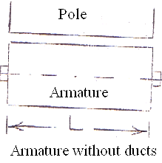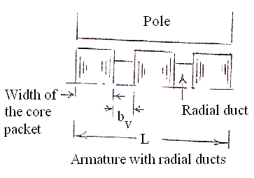

It is clear from the figure that the net core length = (L – nvbv)
wherenv – number of ventilating ducts and bv – width of the ventilating duct.

Since the core is laminated to reduce the eddy current loss and flux takes the least reluctance path, flux confines to the iron only. Therefore the length over which the flux passes is not L or (L -nvbv) but less than that. Generally the thickness of insulation on the laminated core will be

around 10% of the gross core length. Therefore the net iron length will be 0.9 times the net core length or net iron length,
Li = Ki (L - nvbv)
where Ki is called the iron or stacking factor and is approximately 0.9 in practice.

Estimation of number of ventilating ducts

Determine the number of ducts if the length of armature core is 35 cm.

Since the width of the core packet lies between 5 and 7 cm, let the width of the core packet be 6 cm. Therefore number of core packets is equal to 35 /6 or 6 say. Six core packets lead to 5 ducts. If the width of the duct is assumed to be 1.0 cm, then the net core length will be (35 – 1
  - 5) = 30 cm and each core packet after revision will be 30 / 6 = 5 cm in width.

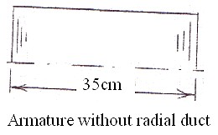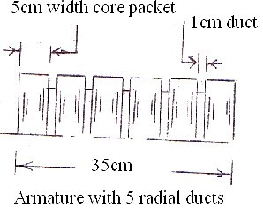

CHOICE OF NUMBER OF POLES

In order to decide what number of poles (more or less) is to be used, let the different factors affecting the choice of number of poles be discussed based on the use of more number of poles.

1. Frequency
As the number of poles increases, frequency of the induced emf f =
PN increases, core
120

loss in the armature increases and therefore efficiency of the machine decreases.

Weight of the iron used for the yoke

Since the flux carried by the yoke is approximately φ /2 and the total flux φ T = pφ is a constant for a given machine, flux density in the yoke

By =
φ / 2
cross sectionalarea of the yoke Ay
= φT
2 P Ay
∝ 1 .
P Ay

It is clear that Ay is ∝ 1/P
as By is also almost constant for a given iron. Thus, as the number of poles increases, Ay and hence the weight of iron used for the yoke reduces.

Weight of iron used for the armature core (from the core loss point of view)

Since the flux carried by the armature core is φ /2, eddy current loss in the armature core
∝ B2 f 2
c
2

∝ [ φ / 2]2
Ac
f 2 ∝
[ φT ] 2 P Ac
× [ P N]2
120

∝ 1 is independent of the number of poles.
A
2
c

On the other hand, since the hysteresis loss in the armature core is

∝ B1.6 f ∝ (
φT )1.6 x P N

∝ 1 ,
the armature core area Ac

c 2 P A 120 P0.6
A1.6

∝ 1
P0.6 / 1.6
c c

decreases as the number of poles increases for a given hysteresis loss. Thus

the weight of iron used for the armature core reduces as the number of poles increases.

Weight of overhang copper

For a given active length of the coil, overhang ∝ pole pitch π D/P goes on reducing as the number of poles increases. As the overhang length reduces, the weight of the inactive copper used at the overhang also reduces.
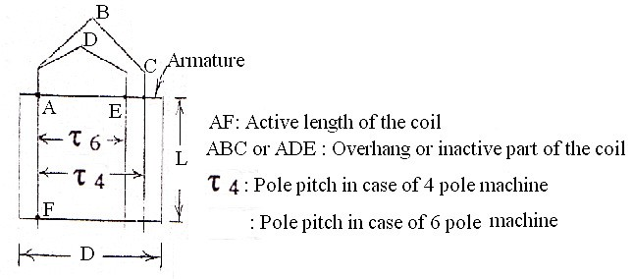

Armature reaction
AT / pole

Since the flux produced by the armature φ a = a
reluctance
and armature ampere turns ATa

/ pole =
Ia Z 2 A P
is proportional to 1 / P, φ
a reduces as the number of poles increases. This

in turn reduces the effect of armature reaction.

Overall diameter
When the number of poles is less, ATa / pole and hence the flux, produced by the armature is more. This reduces the useful flux in the air gap. In order to maintain a constant value of air gap flux, flux produced by the field or the field ampere-turns must be increased. This calls for more field coil turns and size of the coil defined by the depth of the coil df and height of the coil hf increases. In order that the temperature rise of the coil is not more, depth of the field coil is generally restricted. Therefore height of the field coil increases as the size of the field coil or the number of turns of the coil increases. As the pole height, is proportional to the field coilheight, height of the pole and hence the overall diameter of the machine increases with the increase in height of the field coil.

Obviously as the number of poles increases, height of the pole and hence the overall diameter of the machine decreases.

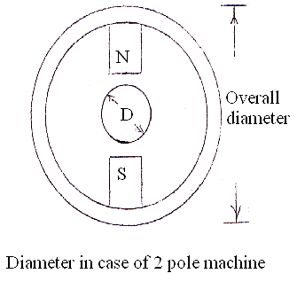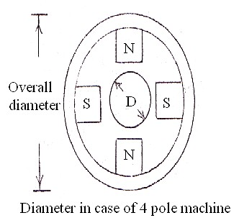

Length of the commutator
Since each brush arm collects the current from every two parallel paths, current / brush arm
= 2 Ia / A and the cross sectional area of the brush / arm Ab = 2Ia / Aδb = 2Ia / Pδb
∝ 1 / P
reduces as the number of poles increases.
As Ab = tbwbnb and tb is generally held constant from the commutation point of view, wbnb reduces as Ab reduces. Hence the length of the commutator
Lc = (wbnb + clearances) reduces as Ab reduces or the number of poles increases.

wb – width of the brush, tb – thickness of the brush, nb – number of brushes per spindle

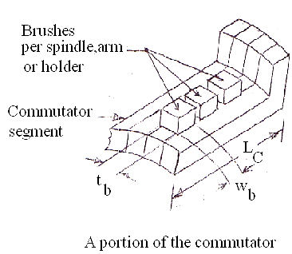

Flash over
As the number of poles increases, voltage between the segments
E = voltage between positive and negative brushes increases. Because of the increased
b number of segments / pole
value of Eb and carbon dust collected in the space where the mica is undercut, chances of arcing between commutator segments increases. The arc between the segments in turn may bridge the positive and negative brushes leading to a dead short circuit of the armature or flash over.

Labour charges
As the number of poles increases cost of labour increases as more number of poles are to be assembled, more field coils are to be wound, placed on to the pole, insulate, interconnect etc.

It is clear that, when the number of poles is more, weight of iron used for yoke and armature core, weight of inactive copper, overall diameter, length of commutator and effect of armature reaction reduces. On the other hand efficiency reduces chances of flash over increases and cost of machine increases.

Since the advantages outnumber the disadvantages, more number of poles is preferable.

Thus, though more number of poles is preferable, it is not advisable from the cost point of view. In general the number of poles should be so selected that good operating characteristics are obtained with minimum weight of active material and minimum cost of construction.

SELECTION OF NUMBER OF POLES (For a preliminary design)

As the armature current increases, cross sectional area of the conductor and hence the eddy current loss in the conductor increases. In order to reduce the eddy current loss in the

conductor, cross-sectional area of the conductor must be made less or the current / path must be restricted.
For a normal design, current / parallel path should not be more than about 200A. However, often, under enhanced cooling conditions, a current / path of more than 200A is also being used. By selecting a suitable number of paths for the machine, current / path can be restricted and the number of poles for the machine can be decided.
While selecting the number of poles, the following conditions must also be considered as far as possible.
  - Frequency of the armature induced emf f = PN/120 should as for as possible between 25 and 50 Hz.
  - Armature ampere turns / pole = IaZ / 2AP should not be greater than 10000.

Example: Select a suitable number of poles for a 1000kW, 500V DC machine.

Armature current (approximately) Ia =
1000 x 103
500

= 2000A

In order that the current / path is not more than about 200A, lap winding has to be used

having number of parallel paths =
2000 = 10 .
200
Since the number of parallel paths is equal

to number of poles in a simplex lap winding, 10 poles can be selected for the machine as a preliminary value. (The number of poles selected can also be like 8 or 12).

Example: Select a suitable number of poles for a 100kW, 500V DC machine.

Armature current (approximately) Ia=
1000 x 103
500

= 200A .

For a current of 200A a lap or wave winding can be used. Since the minimum number of paths and poles is two, 2 poles are sufficient for the machine. However to gain more advantages of more number of poles, let the number of poles be 4.

ARMATURE WINDING

The armature winding can broadly be classified as concentrated and distributed winding.
In case of a concentrated winding, all the conductors / pole is housed in one slot. Since the conductors / slot is more, quantity of insulation in the slot is more, heat dissipation is less, temperature rise is more and the efficiency of operation will be less. Also emf induced in the armature conductors will not be sinusoidal. Therefore
- design calculations become complicated (because of the complicated expression of non- sinusoidal wave).
- Core loss increases (because of the fundamental and harmonic components of the non- sinusoidal wave) and efficiency reduces.
- Communication interference may occur (because of the higher frequency components of the non-sinusoidal wave).

Hence no concentrated winding is used in practice for a DC machine armature.

In a distributed winding (used to overcome the disadvantages of the concentrated winding), conductors / pole is distributed in more number of slots. The distributed winding can be classified as single layer winding and double layer winding.

In a single layer winding, there will be only one coil side in the slot having any number of conductors, odd or even integer depending on the number of turns of the coil. In a double layer winding, there will be 2 or multiple of 2 coil sides in the slot arranged in two layers. Obviously conductors / slot in a double layer winding must be an even integer.

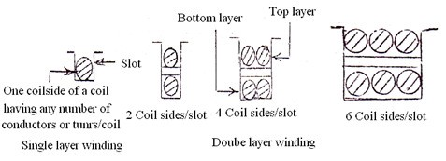

Since for a given number of conductors, poles and slots, a single layer winding calls for less number of coils of more number of turns, reactance voltage proportional to (turn)2 is high. This decreases the quality of commutation or leads to sparking commutation. Hence a single layer winding is not generally used in DC machines. However it is much used in alternators and induction motors where there is no commutation involved.

Since a double layer winding calls for more number of coils of less number of turns/coil, reactance voltage proportional to (turn)2 is less and the quality of commutation is good. Hence double layer windings are much used in DC machines.
Unless otherwise specified all DC machines are assumed to be having a double layer winding. A double layer winding can further be classified as simplex or multiplex and lap or wave winding.

CHOICE BETWEEN A LAP AND WAVE WINDING

Since emf induced or back emf E = φ Z N P
60A

, number of armature conductors Z

= 60EA
φ NP
= KA for given value of E, N and Pφ. K is a constant. Therefore Zlap
= KP, Zwave =

K2 and Zlap=
P
Zwave . It is clear that the number of conductors, coils and commutator
2

segments in a lap winding is more than that of a wave winding for the same number of turns
/coil in both cases. Also since a lap winding is generally equipped with equalizer rings, cost of a lap winding is more than that of a wave winding.

Since a lap winding provides more number of parallel paths, it is generally used for low voltage and high current machines (Ex: machines used for electroplating, battery charging etc). A wave winding is generally used for high voltage and low current machines.

Note:
- A lap winding can be used for any capacity machine. But a wave winding is to be used only for low capacity machines. As the cost of the wave winding is less, almost all low capacity machines employ wave winding.

- While selecting the type of winding the following conditions must also be considered as for as possible.
  - Commutator segment pitch τc = ( π x diameter of the commutator Dc) / number of commutator segments should not be less than 4mm. Otherwise the segments becomes mechanically week. (The value 4mm is applicable to medium capacity machines and must only be taken as a guiding value and need not be strictly followed).

  - Voltage between the commutator segments Eb on open circuit

= emf induced x P
should not be more than 20V. Otherwise arcing between the

number of segments
segments might result. Obviously voltage / conductor should not be greater than 10V on open circuit.

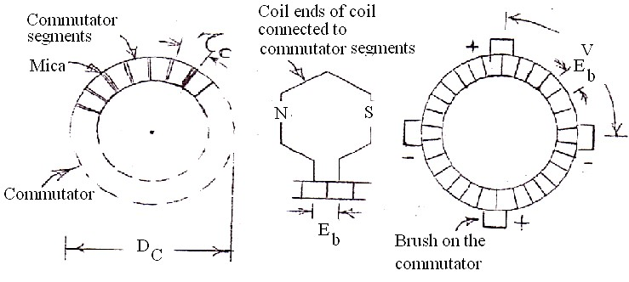

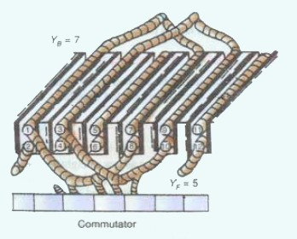
Sketch showing the coil end connection to commutator
segments

NUMBER OF ARMATURE CONDUCTORS

Since the emf induced or back emf
E = φ ZNP , number of armature conductors
60A

Z = 60 EA
where
φ = Bav π DL Wb.For a preliminary design emf induced can be taken as the

φ NP P
terminal voltage in case of a generator and back emf can be taken as the applied voltage in case of a motor.
The number of armature conductors can also be calculated by considering the specific electric

loading. In that case Z =
q A π D . The number of conductors must be an even integer.
Ia

CROSS-SECTIONAL AREA OF THE ARMATURE CONDUCTORS

Since the armature conductors are connected in series in any of the parallel paths of dc machine, maximum value of the current to be carried by the conductor is Ia / A and the cross sectional area of the conductor a = Ia / Aδ mm2. The current density δ lies between 4.5 and 7.0 A / mm2 in practice.
Note:
As the current density increases, cross sectional area decreases, resistance of the conductor increases, I2R loss increases and temperature of the machine increases. If the cooling facility is not good, temperature rise will unnecessarily be high. Hence higher value of current density should be used in machines where the peripheral velocity or speed of operation is high or where cooling facility is good.

For the calculated area ‘a’, a round, square or rectangular section conductor can be used. (Trapezoidal section conductor is also used but only in case of squirrel cage rotor of an induction motor for increasing the starting torque).

CHOICE BETWEEN A ROUND AND RECTANGULAR CONDUCTOR

By considering the coil space factor, what type of conductor section is preferable can be decided.
Coil space factor Sf is defined as the ratio of the area of copper in the coil to the area of the coil. That is,

Sf =
where
Area of copper in the coil af Tf
Overall area of the coil hf df
< 1.0

af – cross sectional area of copper or conductor
Tf – number of copper sections (or turns) in the coil df – depth of the coil and hf– height of the coil.
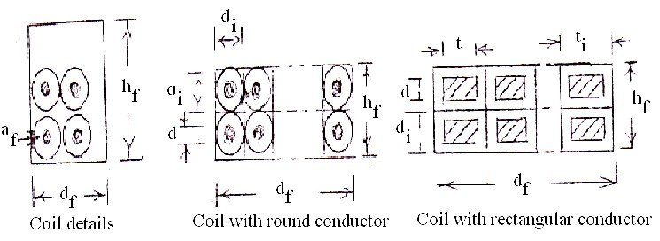

If d is the diameter of the bare conductor and di is the diameter with insulation, then in case of round conductor
2

Sf =
2
( π d
2
d
i
/ 4)
x
x
T/f
T/f
= 0.785 (d / di )

and is always less than 0.785. In practice Sf lies between 0.3 and 0.65 in case of round conductors.

If d and t are the depth and width of the rectangular / square conductor without insulation and di and ti are the depth and width with insulation, then in case of a rectangular /square conductor

Sf =
S = dt x T/f = dt
and lies between 0.7 and 0.85.

[Note:
f
di ti
x T/f
di ti

Since the rectangular conductors can be wound closely without wasting any space in between conductors, Sf in case of a rectangular conductor is more than that of a round conductor of same cross-sectional area.]

If af = 100mm2 andTf = 48, then area of the coil,

h d = af Tf
f f
= 100 x 48

= 8000 mm2 , in case of round conductors with the

Sf 0.6
assumption that Sf = 0.6.

= 100 x 48
0.8
= 6000 mm2 , in case of a rectangular conductors withthe

assumption thatSf = 0.8

It is clear that rectangular conductors call for less space as compared to round conductor of same cross sectional area. Though a rectangular conductor is preferable to round conductor, it is costlier than the round conductors. (Quantity of insulation required in case of a rectangular conductor is more than that of the round conductor. Hence the cost is more). Hence rectangular conductors are used when the conductor cross sectional area is more than about 10 mm2.

DETAILS OF INSULATION

Desirable properties of a good insulator:

- Should have a high dielectric strength
- Should withstand a high temperature
- Should have a high resistivity
- Should not absorb moisture
- Should have a low dielectric hysteresis loss
- Should withstand vibration, abrasion, bending
- Should be flexible and cheap.

No insulating material in practice satisfies all the desirable properties. Therefore materials which satisfy most of the desirable properties must be selected. Based on the temperature withstanding ability, the insulating materials have been classified as indicated below according to ISI (now BIS) – 1271, 1985, first revision.

Class of insulation – Y A E B F H C Maximum temperature 0C – 90 0C 105 0C 120 0C 135 0C 155 0C 180 0C >180

Class Y : Cotton, silk, paper, wood, cellulose, fiber etc., without impregnation or oil immersed.

Class A : The material of class Y impregnated with natural resins, cellulose esters, insulating oils etc., and also laminated wood, varnished paper etc.

Class E : Synthetic resin enamels of vinyl acetate or nylon tapes, cotton and paper laminates with formaldehyde bonding etc.,

Class B : Mica, glass fiber, asbestos etc., with suitable bonding substances, built up mica, glass fiber and asbestos laminates.

Class F : The materials of Class B with more thermal resistance bonding materials.

Class H : Glass fiber and asbestos materials and built up mica with appropriate silicone resins.

Class C : Mica, ceramics, glass, quartz and asbestos with binders or resins of super thermal stability.

Insulation on conductors:
In practice, the most important factor influencing the structure of the insulation is the rated voltage of the machine. Based on the rated voltage, electrical machines can be divided into high voltage and low voltage machines. A low voltage machine is a machine the rated voltage of which is below 1000V.

Insulation on the conductors serves as an inter turn insulation and may be enamel, cotton (single cotton covered SCC or double cotton covered DCC), rayon, silk, glass fiber, asbestos etc.

Addition of insulation to
  - Round wires or conductors – (0.015 to 0.075) mm for enamel covering
- (0.2 to 0.35) mm for dcc
  - Strip or rectangular conductors – (0.06 to 0.15) mm for enamel covering
- (0.45 to 0.5) mm for dcc

For commercial voltages (up to 1000V) enameled wires are generally used.
For further details chapter.3, Electrical Machine Design Data Book, A.Shanmugasundaram can be referred.

TYPES OF SLOTS

The slots can be open, semi-closed or closed type. Slots may be parallel sided or tapered (varying width). The tooth may also be of parallel sided or tapered. Whenever a double layer winding is used, slots of parallel sided (or of constant slot width) are to be used.

Plain un-notched slots or slots without wedge portion are used only for low capacity machines. In this case the coils are restricted from coming out of the slot by the use of steel binding wires. This type of slots is used only in machines where the peripheral velocity is not more than about 25 m/s. For machines of higher peripheral velocity ear notched slots or slots with lip and wedge portions are used.

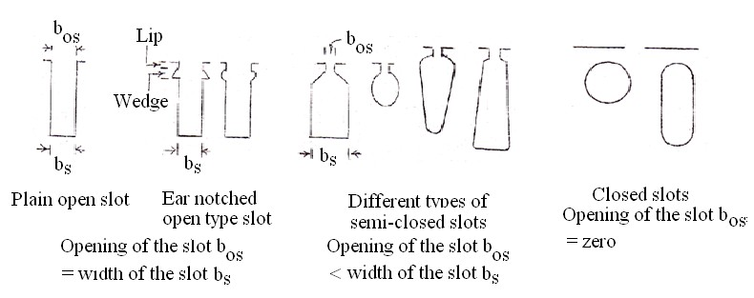
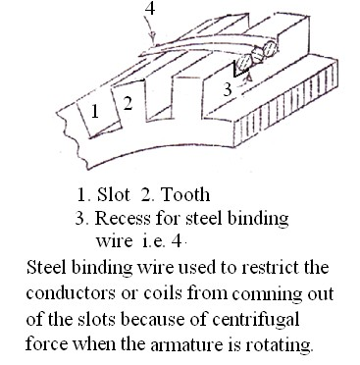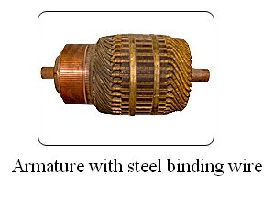

Since wide open slots increases the reluctance of the air gap and causes the flux to pulsate in comparison with the closed or semi closed slots, open slots are not preferable. But open slots offers the advantage of placing the coils into the slots and removing them from the slots easilyfor repair. Also coils can be fully insulated or tapped before being placed into the slots.

With semi closed slots, the coils are to be placed into the slots, turn by turn and therefore it is time consuming and expensive.

With closed slots, preformed coil placement and removal is very difficult and hence no closed slots are used in practice for DC machine armature, stator of alternator or induction motor. However closed slots are used in case of squirrel cage rotor of an induction motor.

In general open type of slots is used in case of high capacity machines and semi closed slots in case of medium and low capacity machines.

NUMBER OF ARMATURE SLOTS

In order to decide what number of slots (more or less) is to be used, the following merits and demerits are considered.
    - As the number of slots increases, cost of punching the slot increases, number of coils increases and hence the cost of the machine increases.
    - As the number of slots increases, slot pitch
λs = (slot width bs + tooth width bt)
= πD/ number of slots S

decreases and hence the tooth width reduces. This makes the tooth mechanically weak, increases the flux density in the tooth and the core loss in the tooth. Therefore efficiency of the machine decreases.
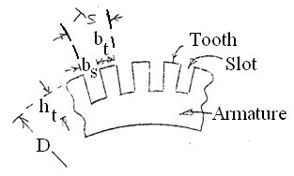

If the slots are less in number, then the cost of punching & number of coils decreases, slot pitch increases, tooth becomes mechanically strong and efficiency increases, quantity of insulation in the slot increases, heat dissipation reduces, temperature increases and hence the efficiency decreases.
It is clear that not much advantage is gained by the use of either too a less or more number of slots.

As a preliminary value, the number of slots can be selected by considering the slot pitch. The slot pitch can assumed to be between (2.5 and 3.5) cm. (This range is applicable to only to medium capacity machines and it can be more or less for other capacity machines).

The selection of the number of slots must also be based on the type of winding used, quality of commutation, flux pulsation etc.

When the number of slot per pole is a whole number, the number slots embraced by each pole will be the same for all positions of armature. However, the number teeth per pole will not be same.

This causes a variation in reluctance of the air gap and the flux in the air gap will pulsate. Pulsations of the flux in the air gap produce iron losses in the pole shoe and give rise to

magnetic noises. On the other hand, when the slots per pole is equal to a whole number plus half the reluctance of the flux path per pole pair remains constant for all positions of the armature, and there will be no pulsations or oscillations of the flux in the air gap.

To avoid pulsations and oscillations of the flux in the air gap, the number of slots per pole should be a whole number plus half. When this is not possible or advisable for other reasons, the number of slots per pole arc should an integer.
Pole shoe
1 2
3 4 5
Number of teeth/pole shoe = 5 and flux passes through 5 teeth.
The reluctance of the air gap is inversely proportional to the area corresponding to 5 teeth.

Pole shoe
1 2
3 4 5 6
Number of teeth/pole shoe = 5 and flux passes through 6 teeth when the armature is moved half tooth pitch to the right.The reluctance of the air gap is inversely proportional to the area corresponding to 6 teeth. The reluctance in this case is less and the flux is more compared to the former case. Therefore, the flux pulsates i.e. Varies in magnitude.
Pole shoe
1 2 3 4 5 6

Number of teeth/pole shoe = (5+ 0.5) and flux passes through 6 teeth.
The reluctance of the air gap is inversely proportional to the area corresponding to 6 teeth.

Pole shoe
1 2 3 4 5 6

Number of teeth/pole shoe = (5+0.5) and flux passes through 6 teeth when the armature is moved half tooth pitch to the right.The reluctance of the air gap is inversely proportional 6 teeth as before. The reluctance and the flux in both the cases remains the same in all positions of the armature. However, the reluctance and the flux under the tips of the pole are not the same for all the positions of armature. Therefore when the armature rotates the flux under the pole oscillates between the pole tips. This produces ripple in the voltage induced in the conductors moving under poles.
Pole

The flux pulsation under inter pole causes the sparking. A small tooth pitch helps to reduce the effect of armature slots upon the inter poles.

To obtain good commutation, the flux density in the air gap must decrease gradually from maximum value under the center of the pole to zero on the center line between two poles, and the flux densities near the neutral point must be low. A field form that drops off rapidly from maximum value to zero not only leads to commutation difficulties but may also give rise to noises in machines with slotted armatures. In order to achieve good commutation the pole shoe is designed to cover only certain percentage of the pole pitch.
The circumferential distance covered by the pole shoe on the armature surface is called the pole arc. The ratio of the pole arc to pole pitch is called per unit embrace or enclosure. That is, per
unit enclosure ψ= Pole arc ≤ 1.0. In practice ψ lies between 0.6 and 0.7.
Pole pitch

In general, the slots between pole tips of two adjacent pole tips i.e. (1-ψ) S
P

should be at

least 3, or
(1-ψ) S ≥ 3 P
If Ψ=0.66,the number of slots per pole,
S ≥ 3 ≥ 8.82 or say 9 P (1-0.66)

Rule to select the number of slots

- From satisfactory commutation point of view, minimum number of slots / pole can be taken as 9.
- To avoid flux pulsation, slots / pole should be an (integer + ½).

- Slot pitch λs = π D/S can assumed to lie between 2.5 and 3.5 cm.
- For a lap winding, number of slots may be multiple of number of poles P or number of pair of poles p (p=P/2) so that equalizer rings can used.
- For a wave winding, number of slots should not be a multiple of number of pair of poles p and should lead to a particular number of coils that makes the commutator or average pitch Yc = [(C ±plex) / p], an integer.

[Note: With a particular number of coils, if Yc does not work out to be an integer, then a wave winding can not be realized. However, it be realized by considering one of the coils as dummy. In that case the number of commutator segments is equal to the number of active coils or (total number of coils – 1). A dummy coil is coil which is electrically inactive. It is made inactive by not connecting its coil ends to the commutator segments. Against its absence, its presence ensures that all the slots are completely filled and armature is mechanically balanced.

Number of coils C = number of slots S x number of coil sides / layer
= number of coil sides / 2

= = Total number of armature conductors Z number of conductors / coil
= Z
2 x conductors / coil side

= Z
2 x number of turns / coil

In general the number of commutator segments is equal to the number of active coils. ]

Size of the armature slots

Width and depth of the slot depends on the number of conductors per slot, cross sectional area of the conductor, rated voltage etc.
[Note:Theinsulation within the slot can be roughly divided into two main categories: ground wall or slot liner and that associated with conductor insulation and their arrangement in the slot.
Slot liner: Protects the winding insulation against any mechanical damage due to roughness of the slot walls and insulate the armature. It also galvanically separates the coil from the iron core of the machine.Materials used generally are Leatheroid,Melinex® polyester films, horn fiber etc.
Separator: Separates and insulates the two layers. Leatheroid, horn fiber, micanite etc., are used.

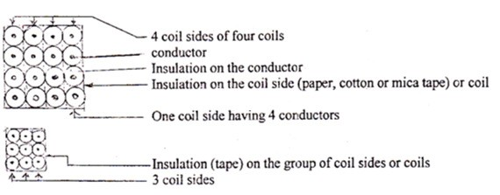

Conductor insulation: Separates the wires and turns of a coil. Usually, standards are not as high for conductor insulation as they are for slot liner insulation, and therefore the former is usually notably thinner than the latter. Consequently a conductor or turn to turn insulation is usually, and in small machines in particular, a varnishing on the wire.]
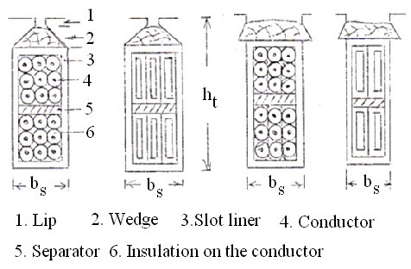

Slot width bs = (Width or diameter of the conductor + insulation on it) number of conductors along the width of the slot + (insulation over the coil or group of coils + slot liner + clearance)

Slot depth ht = (Depth or diameter of the conductor + insulation on it) number of conductors along the depth of the slot + (insulation over the coil or group of coils + separator + slot liner + clearance) + wedge 3 to 5 mm + lip 1 or 2 mm.

For a preliminary design, widthwise sum of insulation over the coil or group of coils, slot liner and clearance can be taken as 1.5mm and depth wise sum of insulation over the coil or group of coils, separator, slot liner and clearance 4mm.

For a given slot pitch, as the slot width and depth increases, the tooth width becomes less and it will be mechanically weak. In general bs should not be greater than 60% of slot pitch. The slot width and depth must be so selected that the flux density in the tooth at one third height from the root of the tooth Bt1/3 is not greater than 2.1T. That is

B = φ should not be more than 2.1T
t

1/3
b L
1/3
t
i
x S/P

b
t
1/3
= width of the armature tooth at 1/3 height from the root of the tooth

= λs – b
s
1/ 3
= π (D - 4/3 ht )
S

- bs

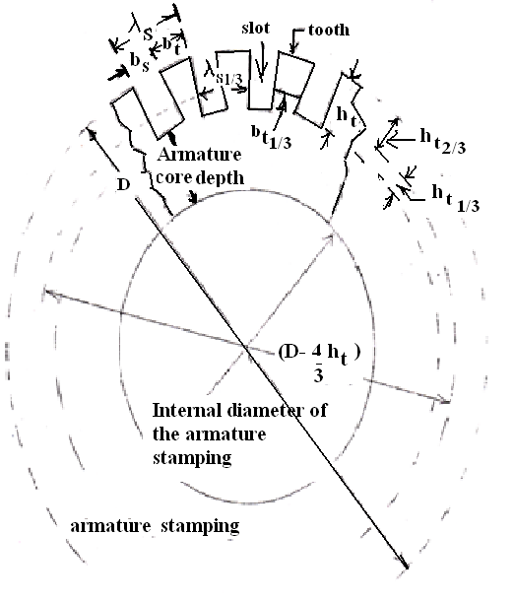

Armature core depth dc:
Flux density in the armature core Bc =
φ /2

φ / 2 dc Li

lies between (1.0 and 1.5)T. With an assumed

value of Bc , dc =
Bc Li
can be calculated.

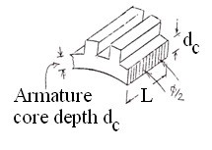

Therefore the internal diameter of the armature = (D – 2ht - 2dc ).

**********

