DESIGN OF TRANSFORMERS

Classification:

Based on the number of phases: single or three phase
Based on the shape of the magnetic media: core or shell type Based on the loading condition: power or distribution type

Design features of power and distribution type transformers:

Power transformer Distribution transformer

- Load on the transformer will be at or near the full load through out the period of operation. When the load is less, the transformer, which is in parallel with other transformers, may be put out of service.
- Generally designed to achieve maximum efficiency at or near the full load. Therefore iron loss is made equal to full load copper loss by using a higher value of flux density. In other words, power transformers are generally designed for a higher value of flux density.
- Necessity of voltage regulation does not arise .The voltage variation is obtained by the help of tap changers provided generally on the high voltage side. Generally Power transformers are deliberately designed for a higher value of leakage reactance, so that the short-circuit current, effect of mechanical force and hence the damage is less.
- Load on the transformer does not remain constant but varies instant to instant over 24 hours a day

- Generally designed for maximum efficiency at about half full load. In order that the all day efficiency is high, iron loss is made less by selecting a lesser value of flux density. In other words distribution transformers are generally designed for a lesser value of flux density.
- Since the distributed transformers are located in the vicinity of the load, voltage regulation is an important factor.
Generally the distribution transformers are not equipped with tap changers to maintain a constant voltage as it increases the cost, maintenance charges etc., Thus the distribution transformers are designed to have a low value of inherent regulation by keeping down the value of leakage reactance.

[ Note : Percentage regulation = I1Rp Cosφ ± I1Xp Sinφ x 100 is less when the value of leakage
V1
Reactance Xp is less, as the primary current I1 is fixed & resistance of the transformer Rp is almost negligible. Ideal value of regulation is zero. ]

Constructional Details of transformer

Outer leg

Central leg
Single-phase core type Transformer Single-phase shell type transformer

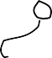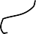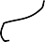2

RR
a
a
a
1
2
3
4
5
R
Y
B

3 phase, 3 leg or limb, core type five limb, three phase core type transformer Transformer [As the size of the transformer increases transportation
difficulties arises because of rail or road gauges. To reduce the height of the transformer, generally a 5-limb core
is used.]

Three phase shell type transformer

Winding arrangement

LV LV

HV

LV

LV

HV
LV
HV

LV |  | HV

LV | HV |  | HV | LV

LV | to | HV | Packing material | Insulation between | Insulation between
HV | to | LV |  | core and coil | LV and HV
Primary |  | Secondary

Unless otherwise specified, LV winding is always placed next to the core and HV winding over the LV winding in order to reduce the quantity of insulation used, avoid the possibility of breakdown of the space between the core and HV coil in case HV coil is provided next to the core and to control the leakage reactance. However in case of transformers where the voltage rating is less, LV and HV windings can be arranged in any manner.

SPECIFICATION

  - Output-kVA
  - Voltage-V1/V2 with or without tap changers and tapings

  - Frequency-f Hz
  - Number of phases – One or three
  - Rating – Continuous or short time
  - Cooling – Natural or forced
  - Type – Core or shell, power or distribution
  - Type of winding connection in case of 3 phase transformers – star-star, star-delta, delta-delta, delta-star with or without grounded neutral
  - Efficiency, per unit impedance, location (i.e., indoor, pole or platform mounting etc.), temperature rise etc.,

SIZE OF THE TRANSFORMER

As the iron area of the leg Ai and the window area Aw = (height of the window Hw x Width of the window Ww) increases the size of the transformer also increases. The size of the transformer increases as the output of the transformer increases.
Aw Ai
Hw
Ww

NOTE:
- Nomenclature:
V1 – Applied primary voltage V2 – Secondary terminal voltage
E1, E2 – EMF induced in the primary and secondary windings per phase in case of 3 phase T1, T2 – Number of primary and secondary turns per phase in case of 3 phase
I1, I2 – Primary and Secondary currents per phase in case of 3 phase
a1, a2 – Cross-sectional area of the primary and secondary winding conductors
δ - Current density in the transformer conductor. Assumed to be same for both LV and HV winding.
φm – Maximum value of the (mutual or useful) flux in weber = AiBm Bm – Maximum value of the flux density = φm / Ai tesla
Ai – Net iron area of the core or leg or limb = KiAg Ki – Iron or stacking factor = 0.9 approximately Ag – Gross area of the core

- V1 V2
= E1
E2
= T1 T2
= I2
I1

a. It is clear that V1I1 = V2I2 or volt-ampere input is equal to volt-ampere output or kVA rating of both primary and secondary windings is same.
b. It is clear that I1T1 = I2T2 or primary mmf is equal to secondary mmf.
c. It is clear that E1/T1 = E2/T2 or volt/turn of both primary and secondary is same.
2. Window space factor Kw
Window space factor is defined as the ratio of copper area in the window to the area of the window. That is
Area of copper in the window Acu
Kw = < 1.0
Area of the window Aw

For a given window area, as the voltage rating of the transformer increases, quantity of insulation in the window increases, area of copper reduces. Thus the window space factor reduces as the voltage increases. A value for Kw can be calculated by the following empirical formula.
10

Kw = where kVhv is the voltage of the high voltage winding expressed in kV.
30 + kVhv

OUTPUT EQUATIONS

- Single phase core type transformer
Rating of the transformer in kVA = V1I1 x 10-3 = E1I1 x 10-3 = 4.44 φm f T1 x I1 x 10-3 …. (1)

a1 a2
H L
L H
H
L
L H
V V
V V
V V
V V

Note: Each leg carries half of the LV and HV turns
I1T1 I2T2 2 I1T1
Area of copper in the window Acu = a1T1 + a2T2 = + = = AwKw
δ δ δ
AwKwδ
Therefore I1T1 = ……… (2) 2
After substituting (2) in (1), kVA = 4.44 AiBmf x AwKwδ x 10-3
2
= 2.22 fδ AiBm AwKw x 10-3

Single phase shell type transformer

Rating of the transformer in kVA = V1I1 x 10-3 = E1I1 x 10-3
= 4.44 φm f T1 x I1 x 10-3 …(1)

HV

LV
a1 a2

LV | HV

[ Note : Since there are two windows, it is sufficient to design one of the two windows as both the windows are symmetrical. Since the LV and HV windings are placed on the central leg, each window accommodates T1 and T2 turns of both primary and secondary windings.]

Area of copper in the window Aw = a1T1 + a2T2 =
I1 T1


- I2 T2


= 2 I1 T2


= Aw Kw

Therefore I1T1 = AwKwδ …. (2)
2
After substituting (2) in (1) kVA = 4.44 AiBmf x AwKwδ x 10-3
2
= 2.22 f δ AiBm AwKw x 10-3

Three phase core type transformer

Rating of the transformer in kVA = V1I1 x 10-3 = E1I1 x 10-3 = 3 x 4.44 φm f T1 x I1 x 10-3 …(1)

H

 |  | R L H H L Y L H H L V V V V V V V V
H V | L V | R L H H L Y L H H L V V V V V V V V | L V | H V
[Note: Since there are two windows, it is sufficient to design one of the two windows, as both the windows are symmetrical. Since each leg carries the LV &HV windings of one phase, each window carry the LV & HV windings of two phases]

Since each window carries the windings of two phases, area of copper in the window, say due to R & Y phases
Acu = (a1T1 + a2T2) + (a1T1 + a2T2)

= 2(a1T1 + a2T2) = 2( I1T1 + I2T2)
δ δ
= 2 x 2 I1T1 = Aw Kw
δ
Therefore I1T1 = AwKw δ …. (2)
4

After substituting (2) in (1)

kVA = 3 x 4.44 AiBmf x AwKwδ x 10-3 = 3.33 f δ AiBm AwKw x 10-3
2

Three phase shell type transformer
R
Rating of the transformer in kVA = 3V1I1 x 10-3
= 3E1I1 x 10-3
= 3 x 4.44 φm f T1 x I1 x 10-3 …(1)
Y

B

[ Note: Since there are six windows, it is sufficient to design one of the six windows, as all the windows are symmetrical. Since each central leg carries the LV and HV windings of one phase, each window carries windings of only one phase.]

Since each window carries LV and HV windings of only one phase,

Area of copper in the window Aw = a1T1 + a2T2 = I1T1 + I2T2
δ δ
= 2 I1T1 = AwKw
δ
Therefore I1T1 = AwKw δ …. (2)
2
Substituting (2) in (1),

kVA = 3 x 4.44 AiBmf x AwKwδ x 10-3
2
= 6.66 f δ AiBm AwKw x 10-3

Usual values of current and Flux density:
The value of current density depends on the type of cooling-natural or forced. Upto 25000KVA natural cooling is adopted in practice. The current density lies between 2.0 and 3.2 A/mm2 for natural cooling and between 5.3 and 6.4 A/mm2 for forced cooling.
The flux density lies between 1.1 and 1.4 T in practice.

Note : To solve the output equation, KVA = 2.22 or 3.33 or 6.66 f δ AiBm AwKw x 10-3 having two unknowns Ai and Aw , volt per turn equation is considered.

Volt / turn equation

Rating of the transformer per phase kVA / ph = V1I1 x 10-3 = E1I1 x 10-3
= 4.44 φm f T1 I1 x 10-3
The term φm is called the magnetic loading and I1T1 is called the electric loading. The required kVA can be obtained by selecting a higher value of φm and a lesser of I1T1 or vice-versa.
As the magnetic loading increases, flux density and hence the core loss increases and the efficiency of operation decreases. Similarly as the electric loading increases, number of turns, resistance and hence the copper loss increases. This leads to reduced efficiency of operation. It is clear that there is no advantage by the selection of higher values of I1T1 or φm. For an economical design they must be selected in certain proportion. Thus in practice
φm φm
= a constant Kt or I1T1 = …… (2) I1T1 Kt

Substituting (2) in (1), kVA / ph = 4.44 φm f φm x 10-3 and φm =
Kt x kVA / ph
4.44f x
10-3
Kt

Since the emf induced E1 = 4.44 φm f T1 is in T1 turns, voltage / turn Et = E1/T1= 4.44 φm f = 4.44
f Kt x kVA / ph 4.44f x 10-3

= 4.44f x 103 x Kt x kVA / ph = K
kVA

Where K = 4.44 f x 103 x Kt is another constant and kVA is the rated output of the transformer. The constant K depends on the type of transformer-single or three phase, core or shell type, power or distribution type, type of factory organization etc.,

Emperical values of K : ( 1.0 to 1.2) for single phase shell type
1.3 for three-phase shell type (power) (0.75 to 0.85) for single phase core type
(0.6 to 0.7) for three phase core type (power)
0.45 for three-phase core type (distribution)

Core design
φm
Net iron area of the leg or limb or coreAi = m2
Bm

For a given area Ai, different types of core section that are used in practice are circular, rectangular and square.

[Note: Choice of core section: 10cm 3.16cm
3.56cm

3.16cm 1.0cm

Circular core  If the area is 10cm2, then | Square core  for Ai = 10cm2, side | Rectangular core for Ai = 10cm2 , the
the diameter of the core | of the square = 10 | perimeter = (10+1)2=22cm if
=3.56cm and the | = 3.16 cm and perimeter | the sides of the rectangular
Circumference = | is 4x3.16=12.64cm | are assumed to be 10cm and 1.0cm
πx3.56=11.2 cm

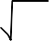
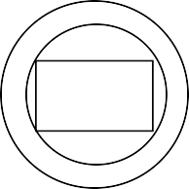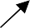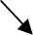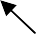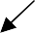It is clear that the rectangular core calls for more length of copper for the same number of turns as compared to circular core. Therefore circular core is preferable to rectangular or square core.
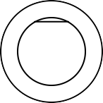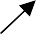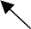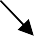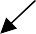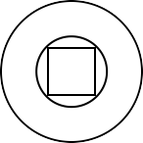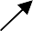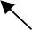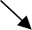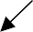
Mechanical forces
Circular coil on a | Round coil on | Square coil on | Circular coil on a | Rectangular coil
Circular core | a square core | a square core | rectangular core | on a rectangular
 |  |  |  | core

Very high values of mechanical forces under short circuit conditions tries to deform the shape of the square or rectangular coil (the mechanical forces try to deform to a circular shape) and hence damage the coil and insulation. Since this is not so in case of circular coils, circular coils are preferable to square or rectangular coils.
Thus a circular core and a circular coil is preferable. Since the core has to be of laminated type, circular core is not practicable as it calls for more number of different size laminations and poses the problem of securing them together is in position. However, a circular core can be approximated to a stepped core having infinite number of steps. Minimum number of steps one and the number of steps in practice is limited to a definite number. Whenever a stepped core is employed a circular coil is used.

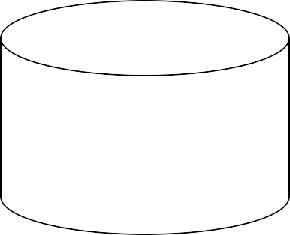
Laminated circular core Stepped core approximated to a circular core

Leg or limb section details: -
The different types of leg sections used are rectangular, square and stepped.

Rectangular core (with a rectangular coil)

b

a 2a
Leg of a core type Central leg of a
a = width of the stamping or leg
b = gross thickness of the assembled core or width of the transformer

b Ai = net iron area of the leg or limb or core
= a xKi b for a core type transformer Ki = iron factor or stacking factor
2a = width of the central leg b = width of the transformer
Ai = 2a x Kib for a shell type transformer

Transformer shell type transformer

(a) Square core (with a square coil)

a = width of the leg
a = width of the transformer

Ai = Kia2 for a core transformer a 2a = width of the central leg
2a = width of the transformer Ai = Ki (2a)2 for a shell type
a
transformer

(b) Square core (with a circular coil)

a = width of the stamping or leg
d
a

450
= d Sin45 or d Cos45
= 0.71d where d is the diameter of the circumscribing circle
Ai = Kia2 = Ki(0.71d)2
= 0.9 x 0.5d2 for 10% insulation or Ki = 0.9
a
= 0.45d2

Area of the circumscribing circle Ac = πd2/4 = 0.785d2 Therefore Ai = 0.45d2 = 0.573

Ac 0.785d2
It is clear that Ai is only 57.3% of Ac. Rest of the area 42.7% of Ac is not being utilized usefully. In order to utilize the area usefully, more number of steps is used. This leads to 2 stepped, 3 stepped etc core.

Cruciform or 2-stepped core:

a = width of the largest stamping b = width of the smallest stamping
Gross area of the core Ag = ab + 2b(a-b)/2 = 2ab-b2
Since a=d Cosθ and b=d Sinθ
Ag = 2d2 Cosθ Sinθ - d2 Sinθ2 = d2(Sin2θ - Sinθ2)

In order that Ag is maximum,
dAg
dθ
= d2 (2 Cos2θ - 2Sinθ Cosθ)
= d2 (2 Cos2θ - Sin2θ) = 0

That is, 2Cos2θ - Sin2θ = 0

Sin 2θ
or
Cos 2θ
= 2 or Tan2θ = 2 or θ = 31.70

Thus Ag is maximum when θ 31.70. With θ = 31.70 , a = d Cos31.7 = 0.85d and b = d Sin31.7 = 0.53d Ag = 2 x 0.85d x 0.53d – (0.53d)2 = 0.62d2
Ai = KiAg = 0.9 x 0.62d2 = 0.56d2
and Ai = 0.56d2 = 0.71 Ag 0.785d2
It is clear that addition of one step to a square core, enhances the utilization of more space of the circumscribing circle area.

Three stepped core:

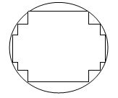

  - Four stepped core:

Width of the largest stamping a = 0.9d Width of the middle stamping b = 0.7d Width of the smallest stamping c = 0.42d Ai =0.6d2

Width of the largest stamping a = 0.93d Ai = 0.62d2
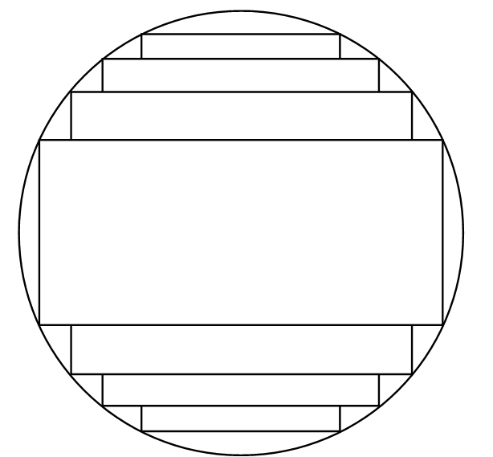

Note : As the number of steps increases, the diameter of the circumscribing circle reduces. Though the cost of the core increases, cost of copper and size of the coil or transformer reduces.

Yoke section details:
The purpose of the yoke is to connect the legs providing a least reluctance path. In order to limit the iron loss in the yoke, operating flux density is reduced by increasing the yoke area. Generally yoke area is made 20% more than the leg area..

Note: 1. Whenever the yoke area is different from the leg area, yoke can considered to be of rectangular type for convenience.
2. In general height of the yoke Hy can be taken as (1.0 to 1.5) a. When there is no data about the yoke area, consider Hy = a.

b
a
a
a

a
a
a
Rectangular leg and yoke Cruciform leg and yoke Rectangular yoke and
Cruciform leg The different types of yoke sections used are square, rectangular and stepped.

Window area and core proportion
kVA
Area of the window Aw = m2
(2.22 or 3.33 or 6.66) fδ Ai BmKw x 10-3
If Hw = height of the window, Ww = width of the window, then Aw = HwWw

In order to limit the leakage reactance of the transformer, Hw is made more than Ww. In practice Hw / Ww lies between 2.5 and 3.5.

D

aa
D

OR
a
a
b

a
Square or rectangular core with square or rectangular coil Stepped leg (Uses only circular coil)
Core type transformer Note: 1. D-distance between the two core or leg central lines
- Width Ww is measured from one edge of the leg to the other of the adjacent leg in case of square or rectangular core with square or rectangular coil and between the two circumscribing circles of adjacent legs in case of stepped legs.
- Depth or width of the core type transformer = b in case of rectangular core
= a in case of square or stepped core
Overall length = (Ww + 2a) or (D+a) in case of single phase core type transformer with square or rectangular core
= (Ww+d+a) or (D+a) in case of single phase core type transformer with a Stepped leg
= (2Ww + 2d + a) or (2D+a) in case of three phase core type transformer with a stepped leg. No square or rectangular leg is used for high capacity three phase transformers.

Overall height = (Hw + 2Hy) for all core type transformers.

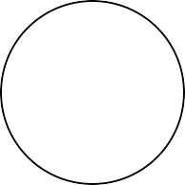
b

2a
Shell type transformer with square Shell type transformer with a stepped
or rectangular core central leg (Calls for a rectangular outer leg)

Depth or width of the Shell type transformer = b in case of rectangular central leg
= 2a in case of stepped central leg

Overall length = (2Ww + 4a) in case of a shell type transformer with rectangular or square central leg
= (d + 2Ww + 2a) in case of shell type transformer with central stepped leg

Overall height = (Hw + 2Hy) in case of a single phase shell type transformer
= 3(Hw+2Hy) in case of a three phase shell type transformer

Winding details:
Since the applied voltage V1 is approximately equal to the voltage induced E1 = 4.44 φm f T1 = Et T1

Number of primary turns (or turns / phase) T1 = V1 / Et in case of single phase transformers
= V1ph / Et in case of 3 phase transformers

Number of secondary turns (or turns / phase) T2 = V2/ Et in case of single phase transformers
= V2ph / Et in case of 3 phase transformers

Primary current (or current/phase) I1 = kVA x 103 / V1 in case of single phase transformers
= kVA x 103 / 3V1ph in case of 3 phase transformers
Cross-sectional area of primary winding conductor a1 = I1/ δ mm2
Secondary current (or current / phase) I2 = kVA x 103 / V2 in case of single phase transformers
= kVA x 103 / 3V2ph in case of 3 phase transformers
Cross-sectional area of secondary winding conductor a2 = I2/ δ mm2
Knowing the number of turns and cross-sectional area of the primary and secondary winding conductors, number of turns/layer in a window height of Hw and number of layers in a window width of Ww can be found out.

No-load current of a transformer
The no-load current I0 is the vectorial sum of the magnetizing current Im and core loss or working component current Ic. [Function of Im is to produce flux φm in the magnetic circuit and the function of Ic is to satisfy the no load losses of the transformer]. Thus,

Io = √ Ic2 + Im ampere.
V1 = - E1
Io
Im
2

Ic
φm
Io
V1
φm

Transformer under no-load condition Vector diagram of Transformer
under no-load condition

No load input to the transformer = V1I0Cosφ0 = V1Ic = No load losses as the output is zero and input = output + losses.

Since the copper loss under no load condition is almost negligible, the no load losses can entirely be taken as due to core loss only. Thus the core loss component of the no load current
core loss

Ic =
V1
for single phase transformers

= core loss / phase
V1 ph
for 3 phase transformers.

RMS value of magnetizing current Im =
Magnetizing ampere turns (Max value)

T1

with the assumption that the magnetizing current is sinusoidal (which is not true in practice)
2

The magnetic circuit of a transformer consists of both iron and air path. The iron path is due to legs and yokes and air path is due to the unavoidable joints created by the core composed of different shaped stampings. If all the joints are assumed to be equivalent to an air gap of lg , then the total ampere turns for the transformer magnetic circuit is equal to AT for iron + 800,000lgBm. Therefore,

Im =
AT for iron + 800,000lgBm

T1
2

Note:
One piece stamping Two piece stamping Impracticable pre-formed (called for the use of
coils on the legs)

- In case of a transformer of normal design, the no load current will generally be less than about 2% of the full load current.
- No load power factor Cosφ0 = Ic/I0 and will be around 0.2.
- Transformer copper losses:
  - The primary copper loss at no load is negligible as I0 is very less.
  - The secondary copper loss is zero at no load, as no current flows in the secondary winding at no load.
- Core or iron loss:
Total core loss = core loss in legs + core loss in yokes.
The core loss can be estimated at design stage by referring to graph of core loss/kg versus flux density.

Core loss in leg = loss/kg in leg x weight of leg in kg
= loss / kg in leg x volume of the leg (AiHw) x density of steel or iron used

Core loss in yoke = loss/kg in Yoke x volume of yoke (Ay x mean length of the yoke) x density of iron used

The density of iron or steel used for the transformer core lies between 7.55 to 7.8 grams/cc.

RESISTANCE AND REACTANCE OF TRANSFORMER

Resistance:

’  T1

2
TP V1 

Resistance of the transformer referred to primary / phase Rp = rp + rs

Resistant of the primary winding/phase rp = (ρLmt) Tp ohm
a1
= rp + rs  or
 T2
or  .
TS 2 
V

Resistivity of copper at 600C ρ= 2.1 x 10-6 ohm-cm or 2.1 x 10-8 ohm-m or 0.021 ohm/m/mm2

Mean length of turn of the primary winding Lmt P = π x mean diameter of the primary winding

Number of primary turns / phase T1 or Tp = V1ph / Et

Resistance of the secondary winding / phase rs = ρLmt Ts
a2

Mean length of turn of the secondary winding Lmt S = π x mean diameter of the secondary winding

Number of secondary turns / phase T2 or Ts = V2ph / Et

2
 T 

Similarly resistance of the transformer referred to secondary / phase Rs = r'p+ rs = rp
 S 
 TP 
+ rs

Reactance:
[Note: 1. Useful flux: It is the flux that links with both primary and secondary windings and is responsible in transferring the energy Electro-magnetically from primary to secondary side. The path of the useful flux is in the magnetic core.
- Leakage flux: It is the flux that links only with the primary or secondary winding and is responsible in imparting inductance to the windings. The path of the leakage flux depends on the geometrical configuration of the coils and the neighboring iron masses.

- Reactance:
  - Leakage reactance = 2πf x inductance = 2πf x Flux linkage / current
  - Flux linkage = flux x number of turns
  - Flux =( mmf or AT) / Reluctance = AT x permeanence ∧
  - Permeanace ∧ = 1 / Reluctance = aμ0μr / l where

a = area over which the flux is established l = length of the flux path

If x p and xs are the leakage reactances of the primary and secondary windings, then the total leakage
reactance of the transformer referred to primary winding Xp = xp + x ' = xp+ xs (Tp/Ts)2.
s
Similarly the leakage reactance of the transformer referred to secondary winding

Xs = x‘
p
+ xs
= xp
(Ts
/ Tp
)2 + xs .

Estimation of the leakage flux or reactance is always difficult, on account of the complex geometry of the leakage flux path and great accuracy is unobtainable. A number of assumptions are to be made to get a usable approximate expression. Validity or the accuracy of the expression is checked against test data.

Expression for the leakage reactance of a core type transformer with concentric LV and HV coils of equal height or length:
Assumptions considered for the derivation:
- Effect of magnetizing current is neglected.
- Reluctance and effect of saturation of iron is neglected.
- All the mmf is assumed to be used to over come the reluctance of coil height
- Leakage flux distribution in coil and in the space between the LV and HV coils is assumed to be parallel to the leg axis.
Let,
bp and bs = Radial depth of primary and secondary windings
Tp and Ts = Number of primary and secondary turns per phase for 3 phase Ip and Is = Primary and secondary currents per phase for 3 phase
Lmt P Lmt S = Mean length of turn of primary or secondary windings respectively

Lmt = Mean length of primary and secondary windings considered together
L0 = Circumference of the insulation portion or duct or both between LV and HV coils Lc = Axial height or length of the both LV and HV coils

The total flux linkage of the primary or secondary winding is due to
- Leakage flux inside the primary or secondary winding and
- Leakage flux in between the LV and HV coils

To determine the flux linkage due to the flux inside the coil, consider an elemental strip dx at a distance ‘x’ from the edge of the LV winding (say primary winding). Then the flux linkage of the primary winding, due to the flux φX in the strip.

ψX = φX x number of turns linked by φX
= ampere turns producing φX permeance of the strip x number of turns linked by φX
= Ip Tpx × Lmt p d x μ0 × Tp x bp Lc bp
Considering the mean length of the strip is approximately equal to Lmt P . Therefore, the total flux linkage due to the flux inside the coil
μ L L bP
p
b
p

ψ = ∫
p
IpT 2
0 mt P
bp L
x2 dx = IpT 2 μ0
mt P x
L 3

0 2 c c

If one half of the flux φ0
in between the LV and HV windings is assumed to be linking with each

windings, then the flux linkage of the primary winding due to half of the flux φ0 in between LV and HV windings,

1
ψ 0 =
2

φ0 x number of turns linked by φ0

= ampere turns producing φ0 x permeance of the duct x number of turns linked by flux φ0 .

= 1 I T
x L0aμ0 x T

p p p
2 Lc
Therefore total flux linkage of the primary winding = ψ + ψ0 = Ip T 2 μ0 (Lmt p bp + L0a )
p
Lc 3 2
= IpTp2 μ0 Lmt p ( bp + a ) with the assumption that Lmt p ≈ L0 Lc 3 2
Therefore leakage reactance of the primary / ph xp = 2πf x flux linkage
Current
= 2πf x IpTp2 μ0 Lmt p ( bp + a )
Lc 3 2 Ip
= 2πf Tp2 μ0 Lmt s ( bp + a ) ohm
Lc 3 2

Similarly leakage reactance of the secondary winding / ph

xs = 2πf TS μ0 Lmt s ( bS + a ) ohm
2
Lc 3 2
Therefore leakage reactance of the transformer referred to primary winding per phase

Xp = xp + x '
s
= xp + xs ( Tp )2
TS

= 2πf Tp2 μ0 [ Lmt p ( bp + a ) + Lmt s ( bS + a ) ] Lc 3 2 3 2
L  bp bs 

= 2πf Tp2 μ0

+
mt

+ a 
ohm

Lc  3 3 

DESIGN OF TANK AND TUBES

Because of the losses in the transformer core and coil, the temperature of the core and coil increases. In small capacity transformers the surrounding air will be in a position to cool the transformer effectively and keeps the temperature rise well with in the permissible limits. As the capacity of the transformer increases, the losses and the temperature rise increases. In order to keep the temperature rise with in limits, air may have to be blown over the transformer. This is not advisable as the atmospheric air containing moisture, oil particles etc., may affect the insulation. To overcome the problem of atmospheric hazards, the transformer is placed in a steel tank filled with oil. The oil conducts the heat from core and coil to the tank walls. From the tank walls the heat goes dissipated to surrounding atmosphere due to radiation and convection. Further as the capacity of the transformer increases, the increased losses demands a higher dissipating area of the tank or a bigger sized tank. This calls for more space, more volume of oil and increases the cost and transportation problems. To overcome these difficulties, the dissipating area is to be increased by artificial means with out increasing the size of the tank. The dissipating area can be increased by

- fitting fins to the tank walls 3. fitting tubes to the tank and
- using corrugated tank 4. using auxiliary radiator tanks

Since the fins are not effective in dissipating heat and corrugated tank involves constructional difficulties, they are not much used now a days. The tank with tubes are much used in practice. Tubes in more number of rows are to be avoided as the screening of the tank and tube surfaces decreases the dissipation. Hence, when more number of tubes are to be provided, a radiator attached with the tank is considered. For much larger sizes forced cooling is adopted.

DIMENSIONS OF THE TANK

The dimensions of tank depends on the type and capacity of transformer, voltage rating and electrical clearance to be provided between the transformer and tank, clearance to accommodate the connections and taps, clearance for base and oil above the transformer etc.,. These clearances can assumed to be between

(30 and 60) cm in respect of tank height
(10 and 20) cm in respect of tank length and
(10 and 20) cm in respect of tank width or

breadth.
1 2 3 36

Tubes spaced at 5 cm apart
185
Header

Tank height Ht = [ Hw + 2Hy or 2a + clearance (30 to 60) cm ] for single and three phase core, and single phase shell type transformers.

= [3(Hw + 2Hy or 2a) + clearance (30 to 60) cm ] for a three phase shell type transformer.

Tank length Lt = [ D + Dext + clearance (10 to 20) cm ] for single phase core type transformer
= [ 2D + Dext + clearance (10 to 20) cm ] for three phase core type transformer

= [ 4a + 2Ww + clearance (10 to 20) cm ] for single and three phase shell type transformer.

Width or breadth of tank Wt = [ Dext + clearance (10 to 20) cm ] for all types of transformers with a
circular coil.
= [ b + Ww + clearance (10 to 20) cm ] for single and three phase core type transformers having rectangular coils.

= [ b + 2Ww + clearance (10 to 20) cm ] for single and three phase shell type transformers.

When the tank is placed on the ground, there will not be any heat dissipation from the bottom surface of the tank. Since the oil is not filled up to the brim of the tank, heat transfer from the oil to the top of the tank is less and heat dissipation from the top surface of the tank is almost negligible. Hence the effective surface area of the tank St from which heat is getting dissipated can assumed to be 2Ht (Lt + Wt) m2.

Heat goes dissipated to the atmosphere from tank by radiation and convection. It has been found by experiment that 6.0W goes radiated per m2 of plain surface per degree centigrade difference between

tank and ambient air temperature and 6.5W goes dissipated by convection / m2 of plain surface / degree centigrade difference in temperature between tank wall and ambient air. Thus a total of 12.5W/m2/0C goes dissipated to the surrounding. If θ is the temperature rise, then at final steady temperature condition,
losses responsible for temperature rise is losses dissipated or transformer losses = 12.5 St θ

Number and dimensions of tubes

If the temperature rise of the tank wall is beyond a permissible value of about 500C, then cooling tubes are to be added to reduce the temperature rise. Tubes can be arranged on all the sides in one or more number of rows. As number of rows increases, the dissipation will not proportionally increase. Hence the number of rows of tubes are to be limited. Generally the number of rows in practice will be less than four.
With the tubes connected to the tank, dissipation due to radiation from a part of the tank surface screened by the tubes is zero. However if the radiating surface of the tube, dissipating the heat is assumed to be equal to the screened surface of the tank, then tubes can assumed to be radiating no heat. Thus the full tank surface can assumed to be dissipating the heat due to both radiation and convection & can be taken as 12.5 Stθwatts.
Because the oil when get heated up moves up and cold oil down, circulation of oil in the tubes will
be more. Obviously, this circulation of oil increases the heat dissipation. Because of this syphoning action, it has been found that the convection from the tubes increase by about 35 to 40%. Thus if the improvement is by 35%, then the dissipation in watts from all the tubes of area At = 1.35 x 6.5Atθ = 8.78 Atθ.
Thus in case of a tank with tubes, at final steady temperature rise condition, Losses = 12.5 Stθ + 8.78 Atθ
Round, rectangular or elliptical shaped tubes can be used. The mean length or height of the tubes
is generally taken as about 90% of tank height.
In case of round tubes, 5 cm diameter tubes spaced at about 7.5cm (from centre to centre) are used. If dt is the diameter of the tube, then dissipating area of each tube at = πdt x 0.9Ht. if nt is the number of tubes, then At = atnt.
Now a days rectangular tubes of different size spaced at convenient distances are being much used, as it provides a greater cooling surface for a smaller volume of oil. This is true in case of elliptical tubes also.
The tubes can be arranged in any convenient way ensuring mechanical strength and aesthetic
view.

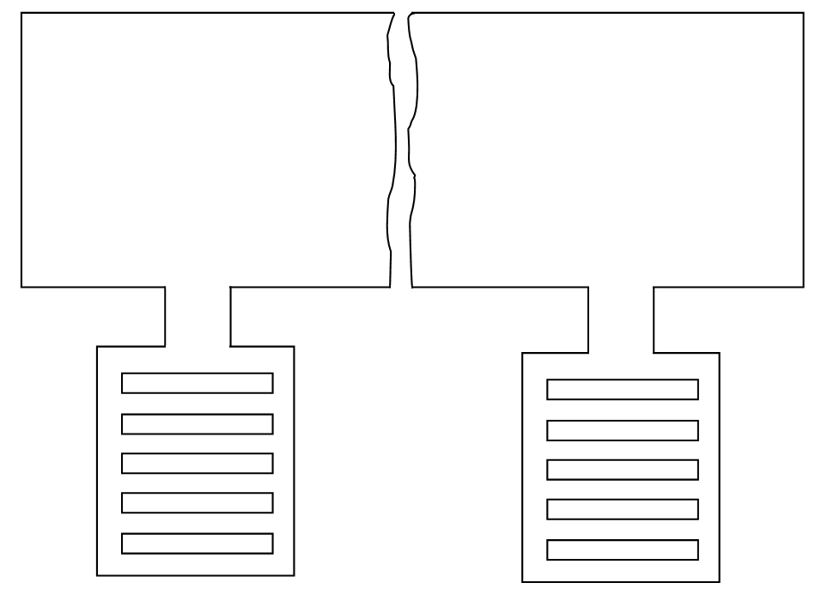

Different ways of tube Different ways of tube arrangement
arrangement (round) (rectangular)

*****************

