### Module 5: Z-Transforms

Z-Transforms – 1: Introduction, Z – transform, properties of ROC, properties of Z – transforms, inversion of Z – transforms.

### TEXT BOOK

**Simon Haykin and Barry Van Veen** “Signals and Systems”, John Wiley & Sons, 2001.Reprint 2002

### REFERENCE BOOKS :

1. **Alan V Oppenheim, Alan S, Willsky and A Hamid Nawab,** “Signals and Systems” Pearson Education Asia / PHI, 2nd edition, 1997. Indian Reprint 2002
2. **H. P Hsu, R. Ranjan**, “Signals and Systems”, Scham‟s outlines, TMH, 2006
3. **B. P. Lathi**, “Linear Systems and Signals”, Oxford University Press, 2005
4. **Ganesh Rao and Satish Tunga**, “Signals and Systems”, Sanguine Technical Publishers, 2004

.

# Module 5

**Z-Transforms**

## Introduction to *z*-transform:

The *z*-transform is a transform for sequences. Just like the Laplace transform takes a function of *t* and replaces it with another function of an auxiliary variable *s*. The *z*-transform takes a sequence and replaces it with a function of an auxiliary variable, *z*. The reason for doing this is that it makes difference equations easier to solve, again, this is very like what happens with the Laplace transform, where taking the Laplace transform makes it easier to solve differential equations. A difference equation is an equation which tells you what the *k*+2th term in a sequence is in terms of the *k*+1th and *k*th terms, for example. Difference equations arise in numerical treatments of differential equations, in discrete time sampling and when studying systems that are intrinsically discrete, such as population models in ecology and epidemiology and mathematical modelling of mylinated nerves.

Generalizes the complex sinusoidal representations of DTFT to more generalized representation using complex exponential signals

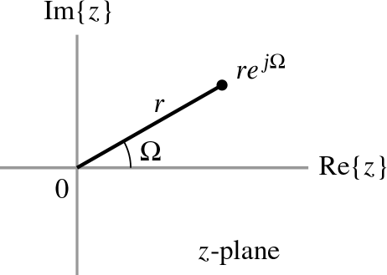

* + It is the discrete time counterpart of Laplace transform

### The *z*-Plane

* + Complex number *z* = *re j* is represented as a location in a complex plane (*z-plane*)

## The *z*-transform:

* + Let *z* = *re j* be a complex number with magnitude*r* and angle  .
  + The signal *x*[*n*] = *zn* is a complex exponential and *x*[*n*] = *rn* cos(*n*)+ *jrn* sin(*n*)
  + The real part of *x*[*n*] is exponentially damped cosine
  + The imaginary part of *x*[*n*] is exponentially damped sine
  + Apply *x*[*n*] to an LTI system with impulse response *h*[*n*], Then

*y*[*n*] = *H*{*x*[*n*]} = *h*[*n*] ∗ *x*[*n*]

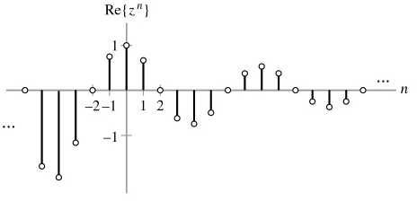

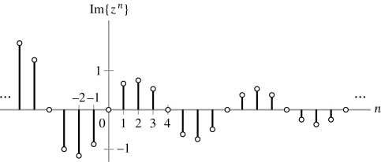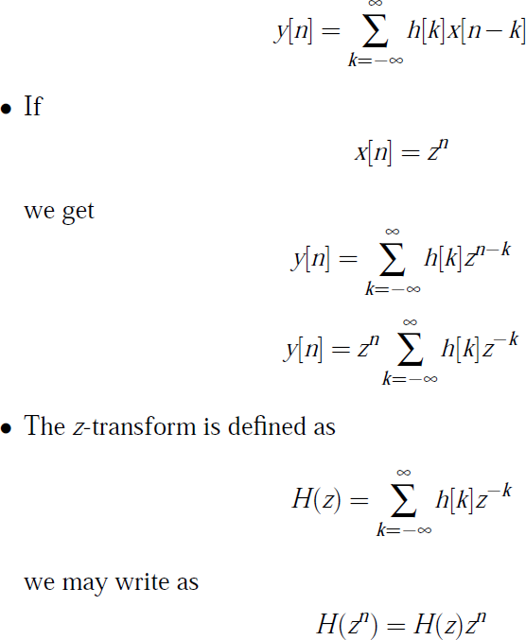

You can see that when you do the *z*-transform it sums up all the sequence, and so the individual terms affect the dependence on *z*, but the resulting function is just a function of *z*, it has no *k* in it. It will become clearer later why we might do this.

* + This has the form of an eigen relation, where *zn* is the eigen function and *H*(*z*) is the eigen value.
  + The action of an LTI system is equivalent to multiplication of the input by the complex number H(z).

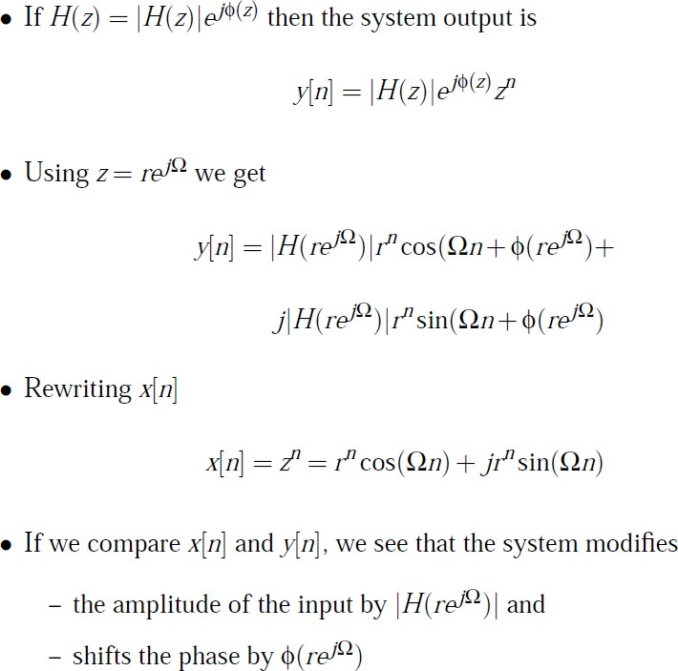

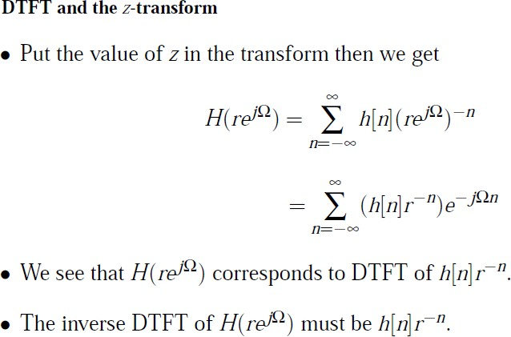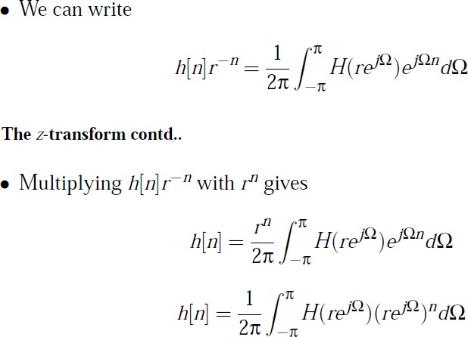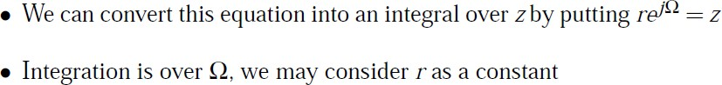

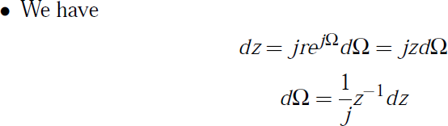

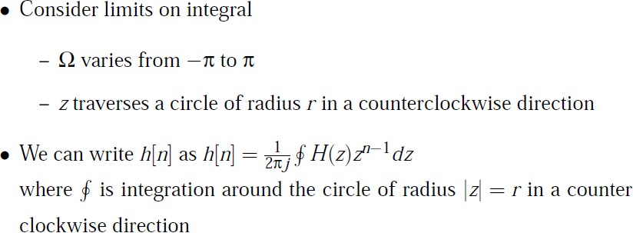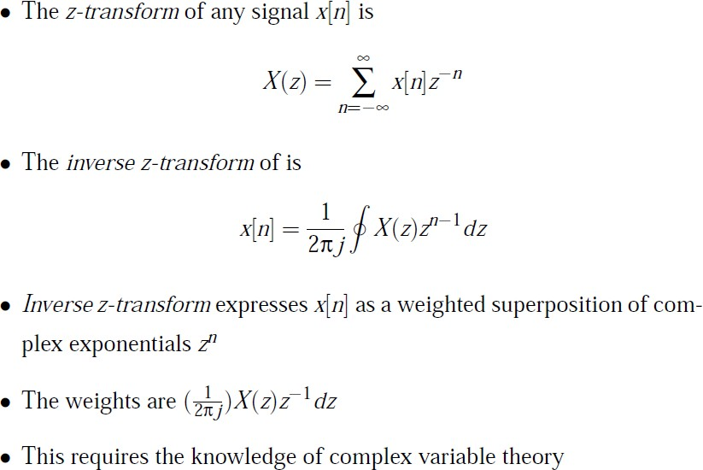

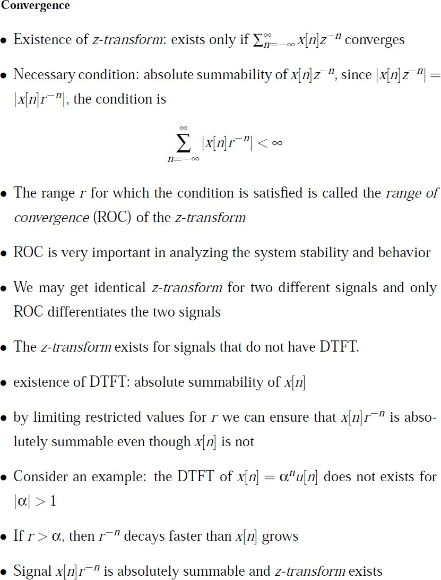

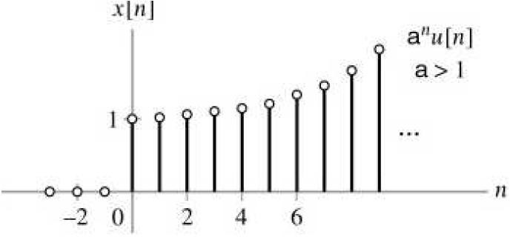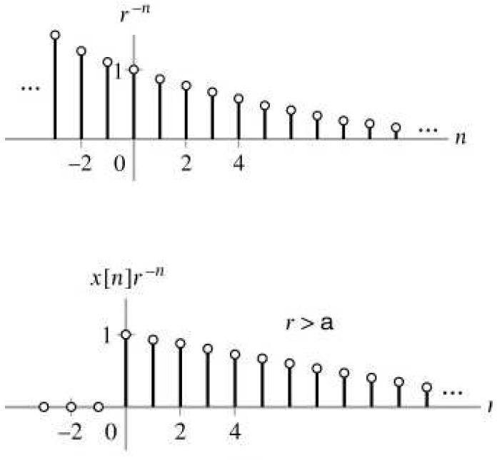

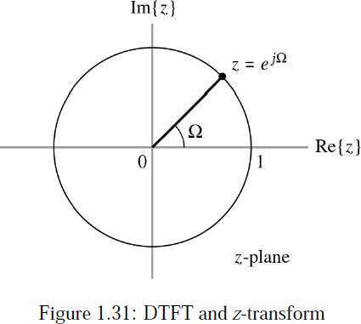

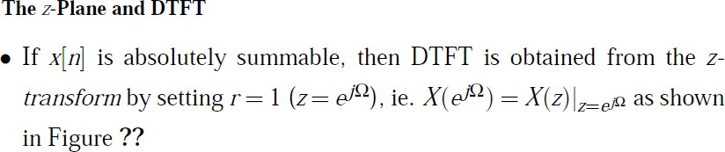

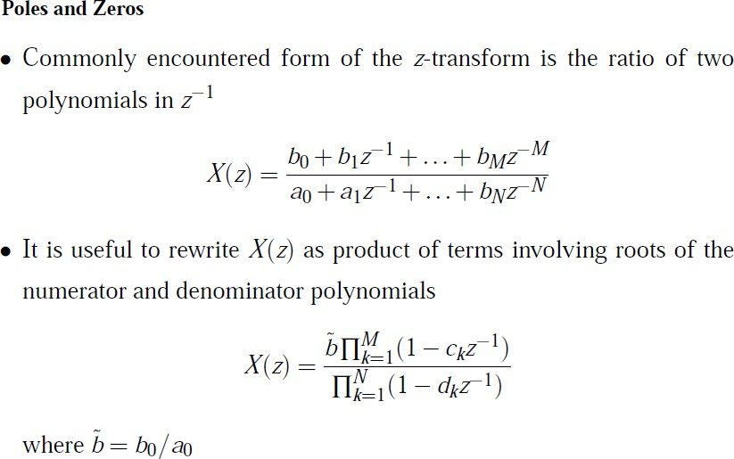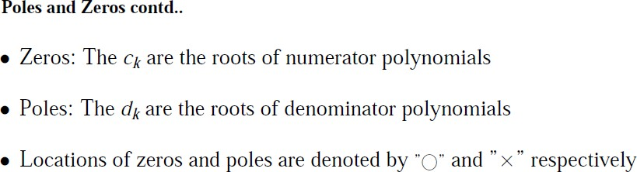

### Example 1:

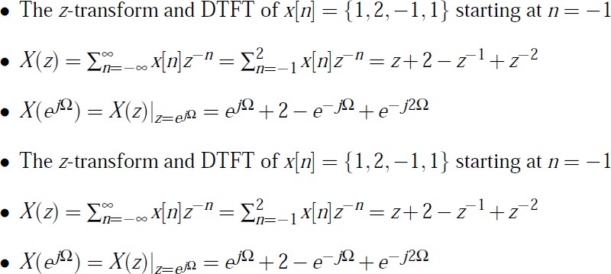

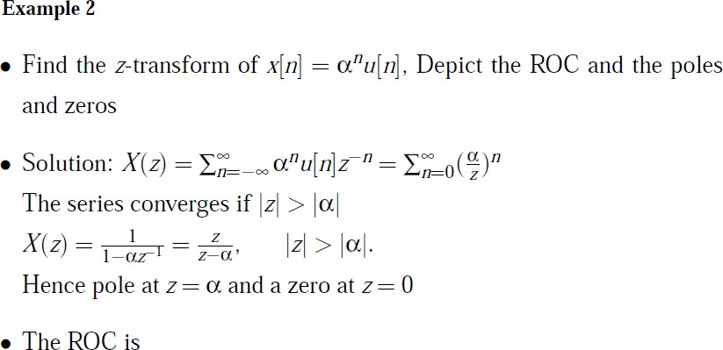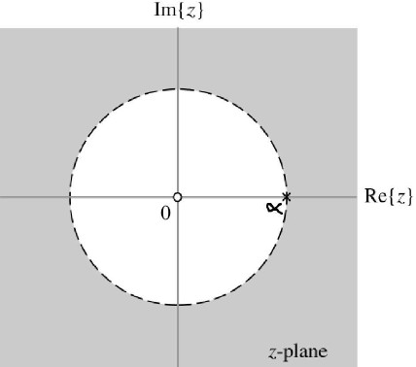

**Properties of Region of Convergence:**

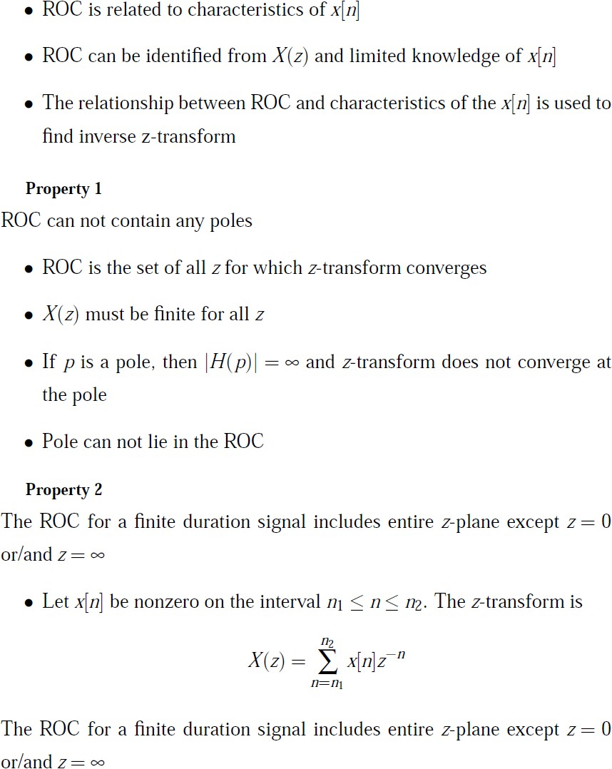

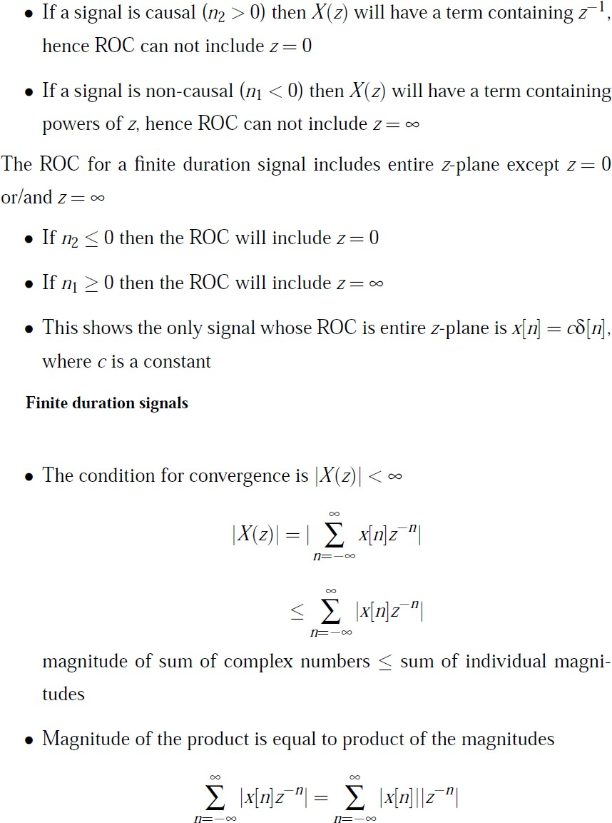

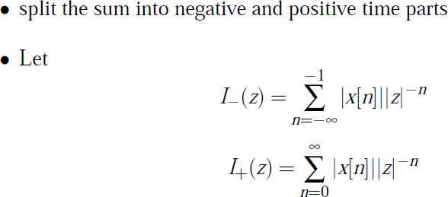

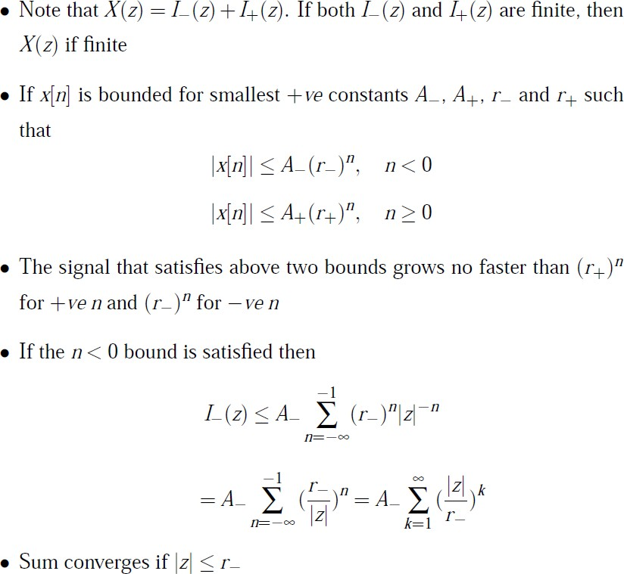

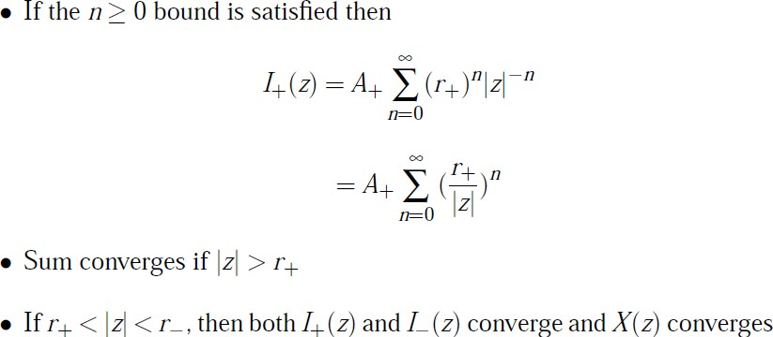

**Properties of Z – transform:**

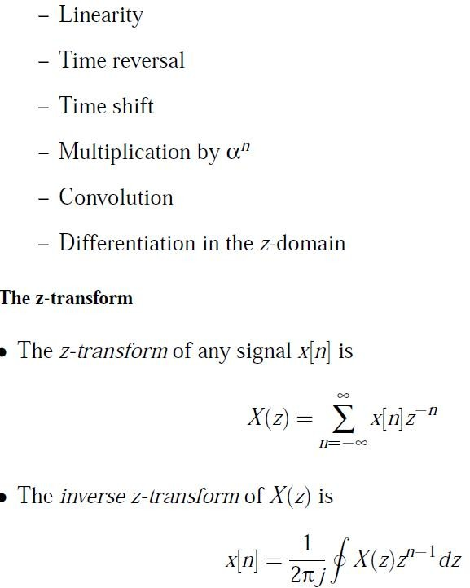

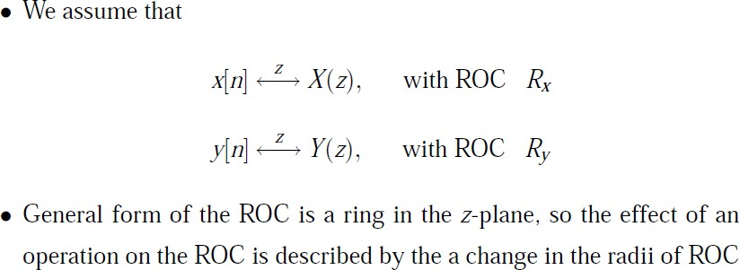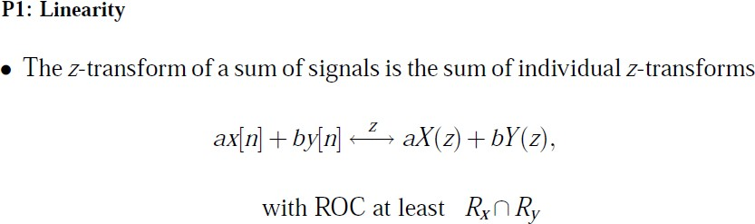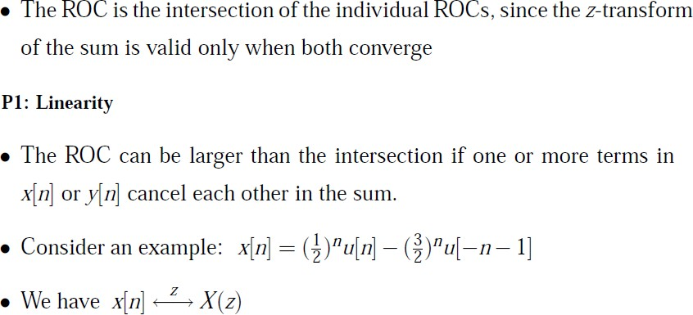

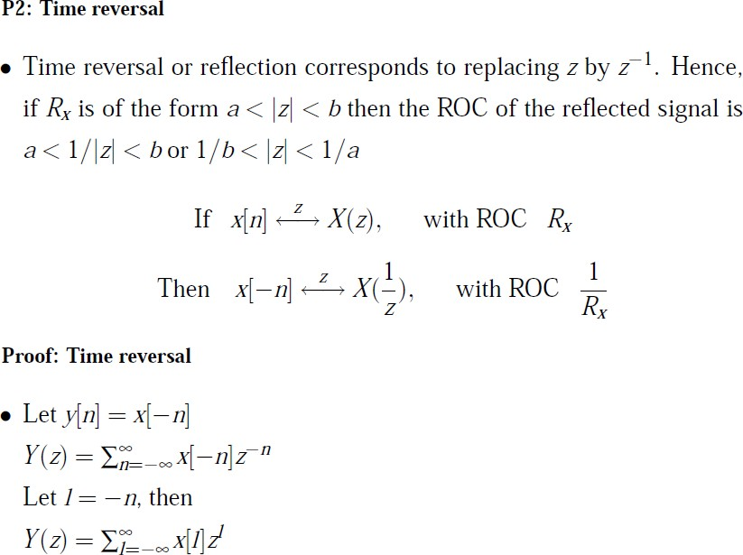

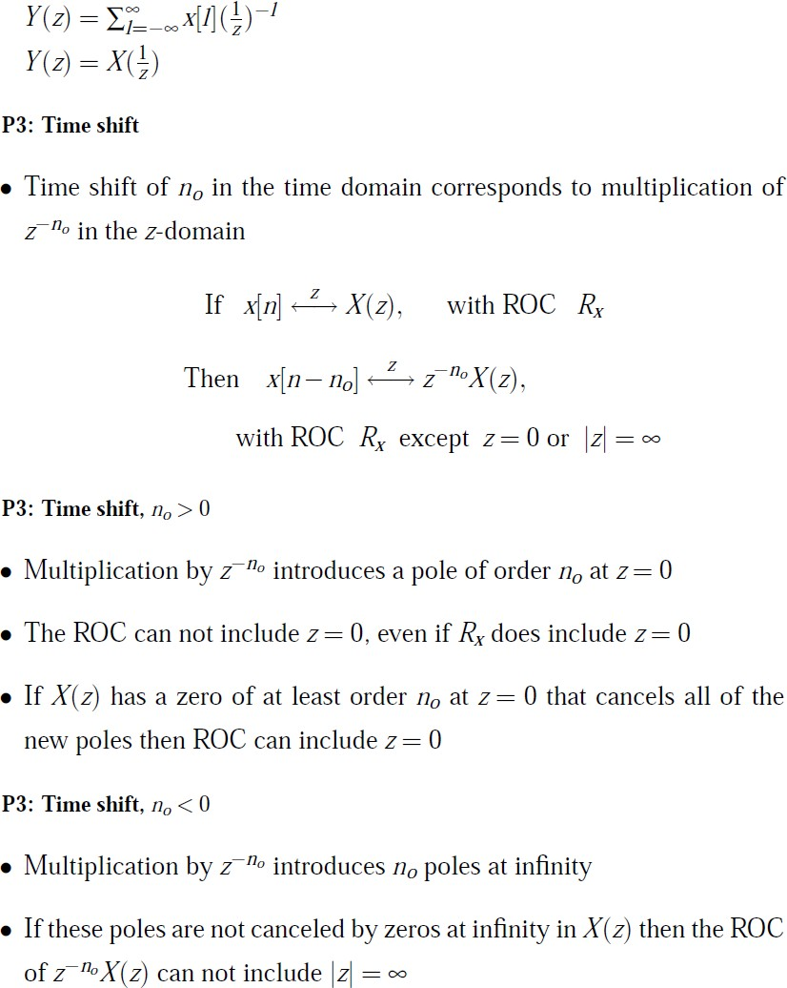

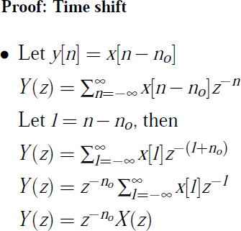

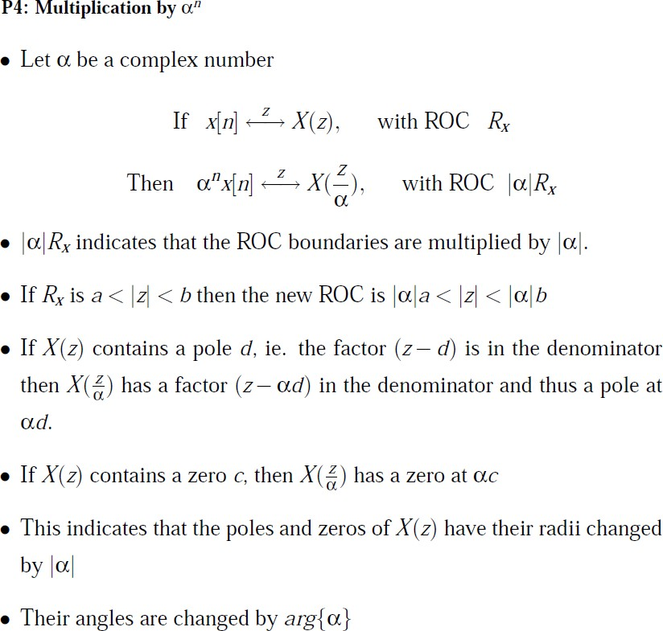

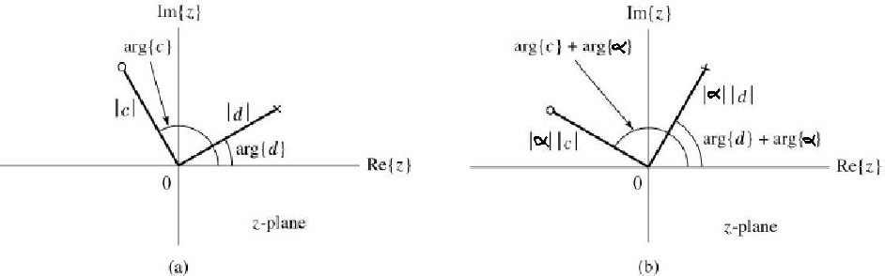

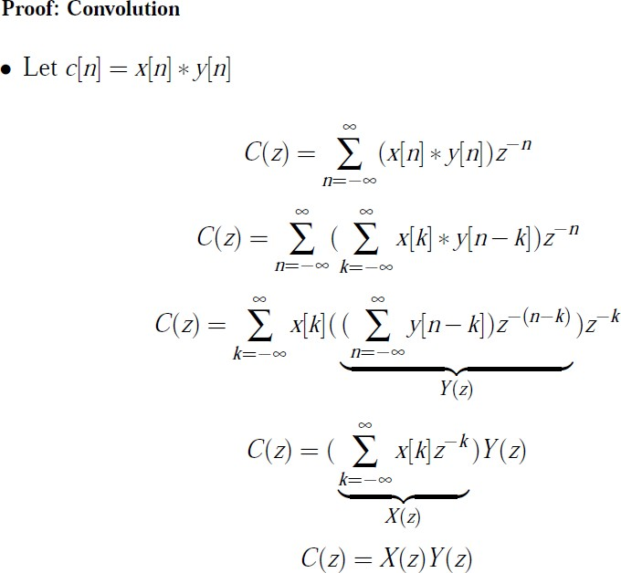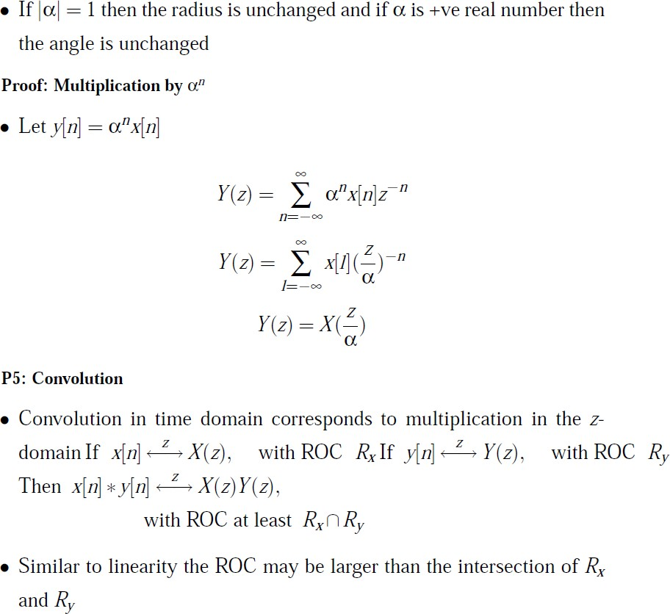

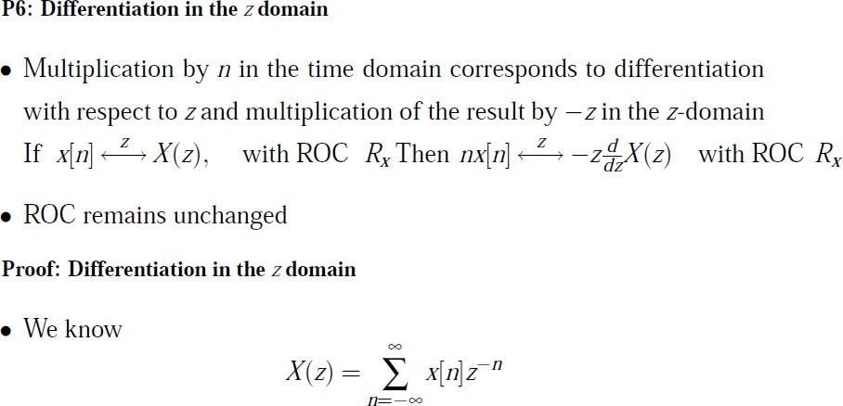

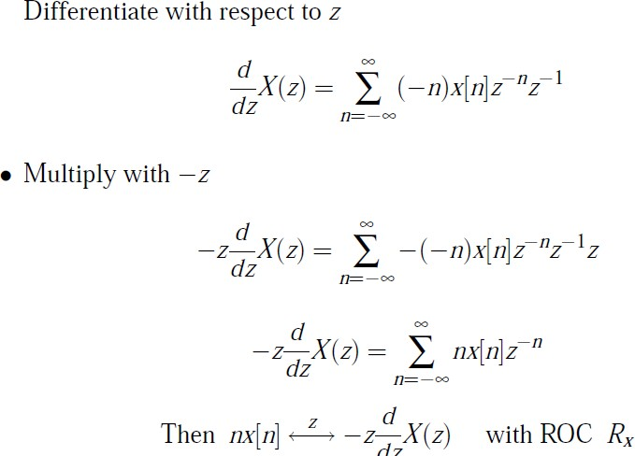

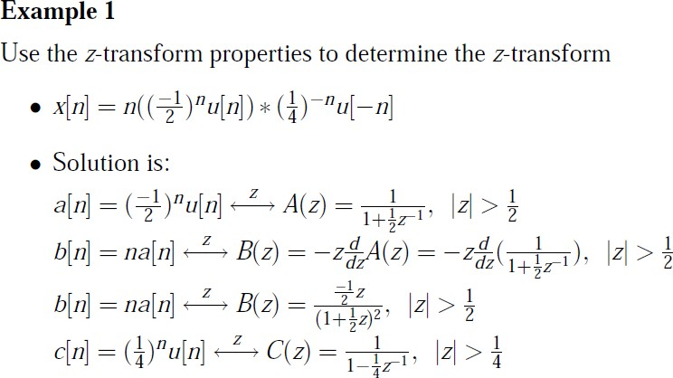

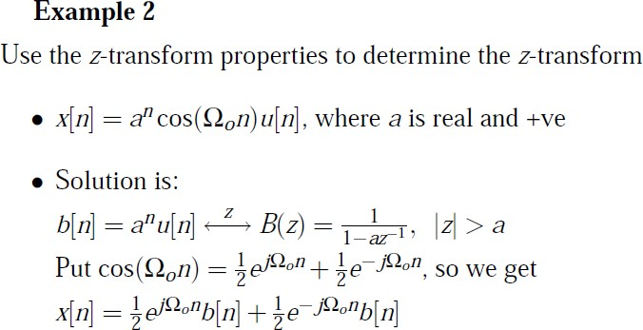

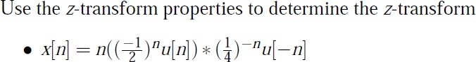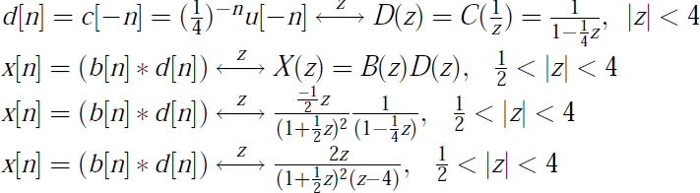

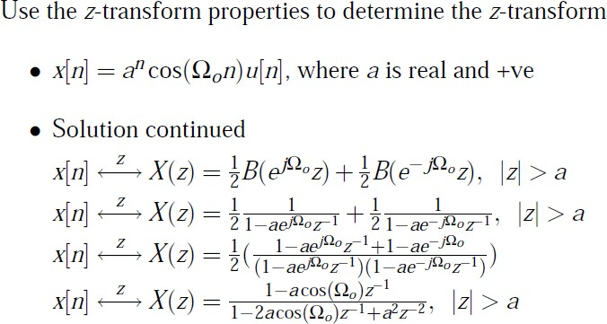

**Inverse Z transform:**

Three different methods are:

* + 1. Partial fraction method
    2. Power series method
    3. Long division method 4.

### Partial fraction method:

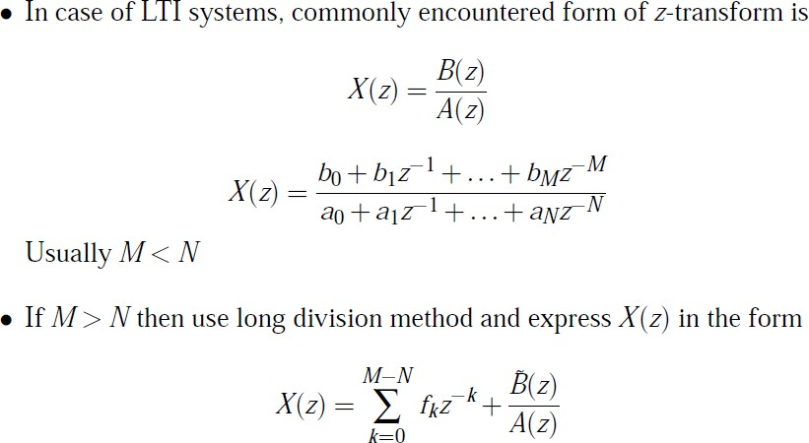

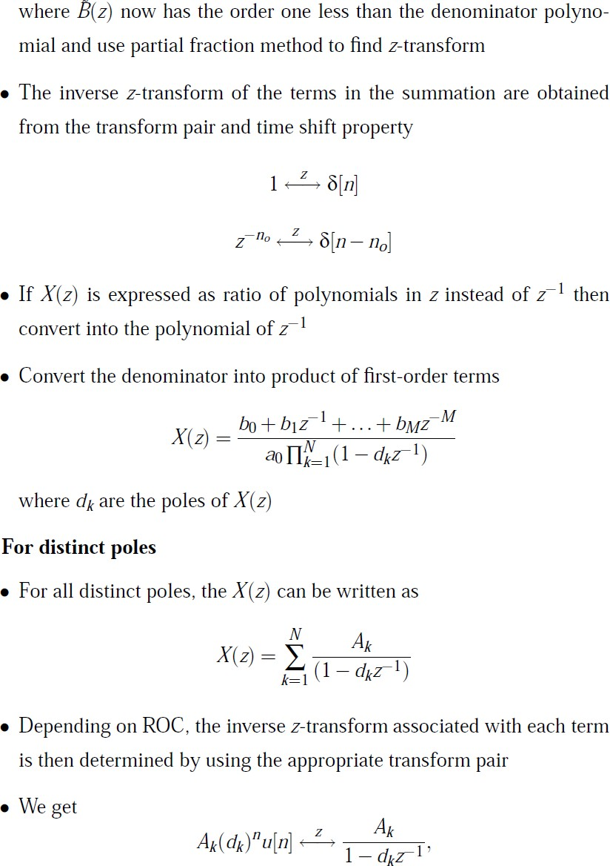

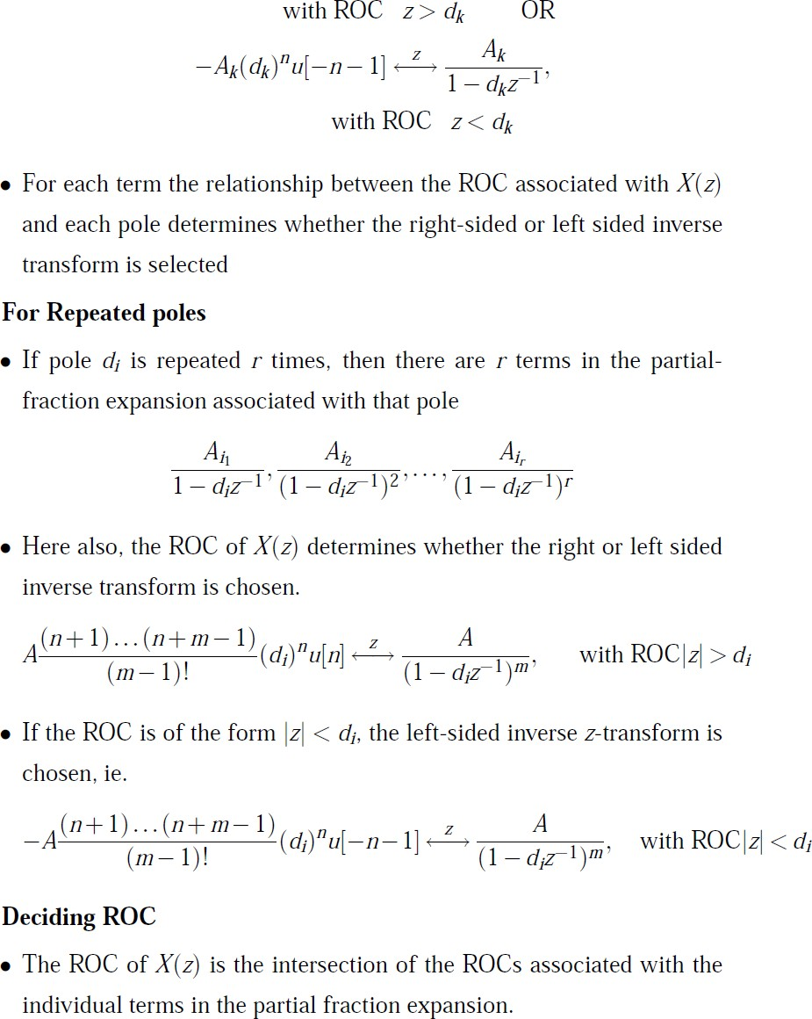

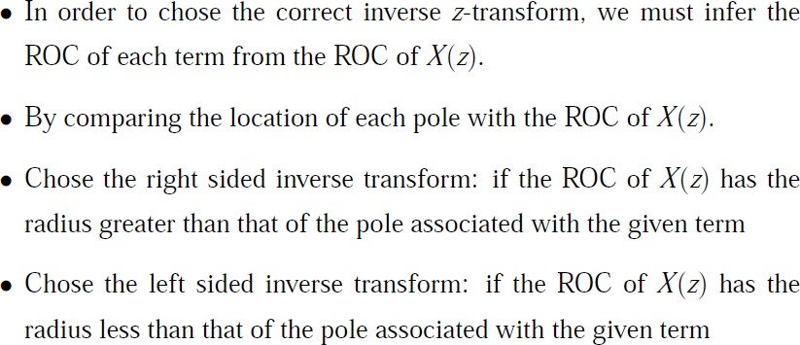

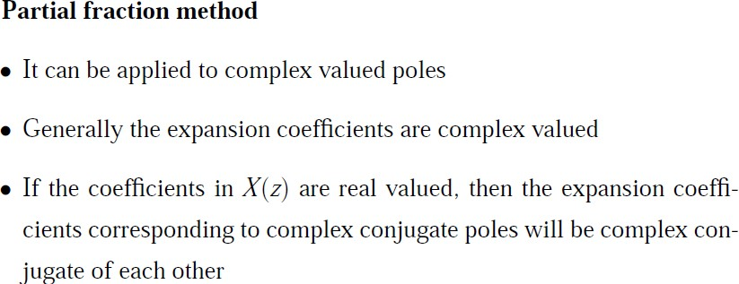

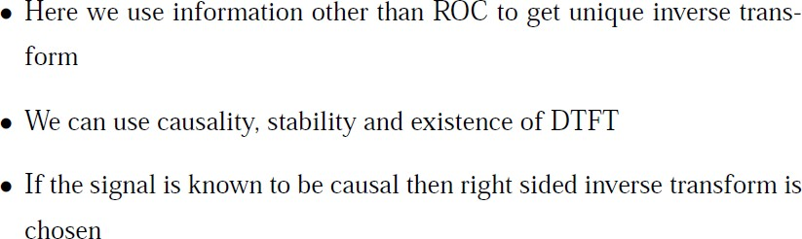

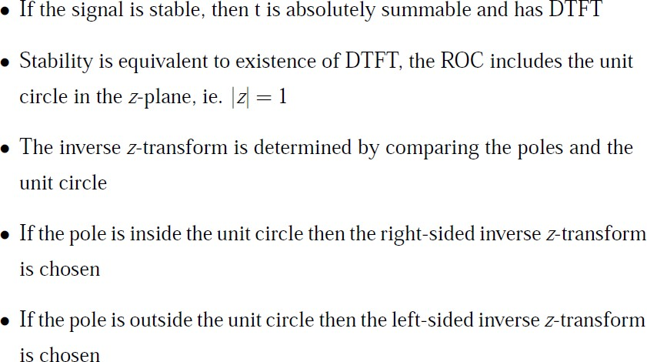

**Power series expansion method**

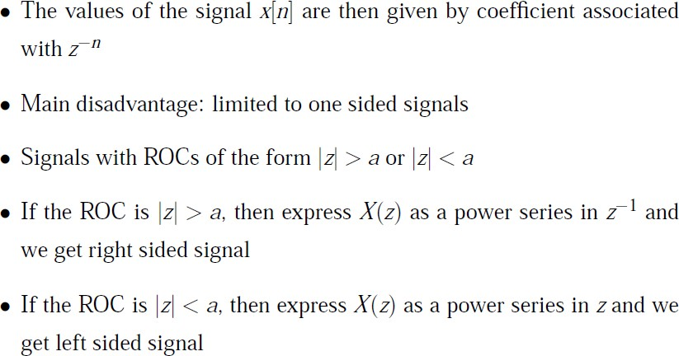

**Long division method:**

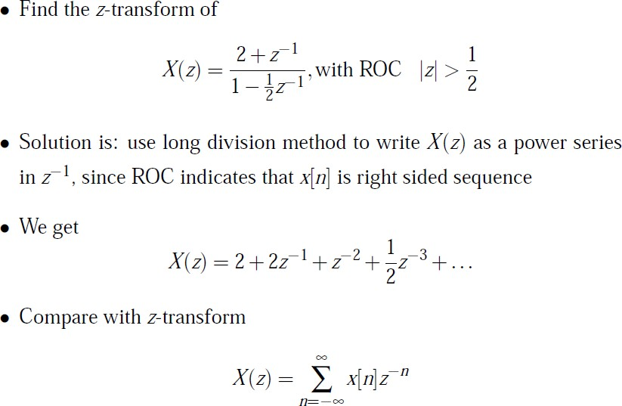

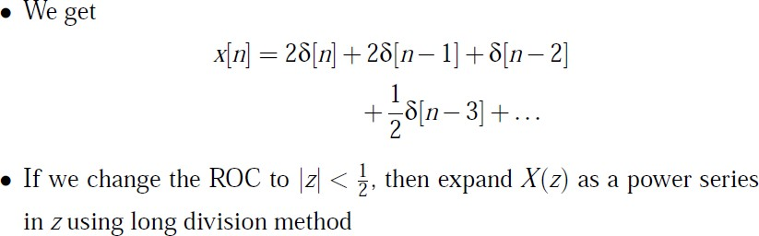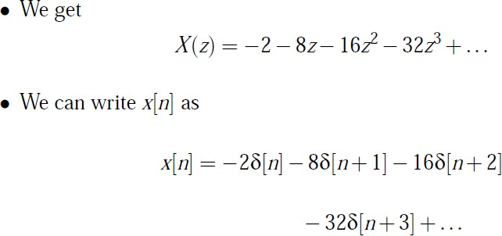

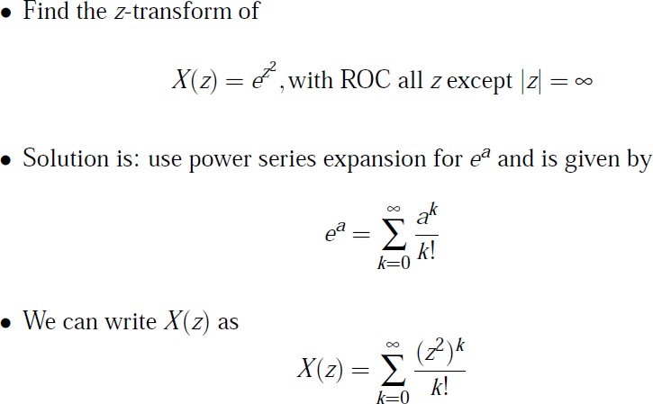

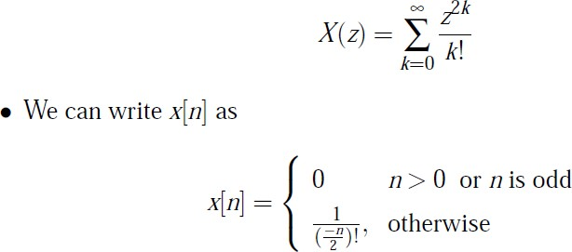

**Recommended Questions**

1. Using appropriate propertes find the Z-transform of x(n)=n2(1/3)nu(n-2)
2. Determine the inverse Z**-** transform of X(z)=1/(2-z-1 **+2** z-2) by long division method
3. Determine all possible signals of x(n) associated with Z- transform X(z)= (1/4) z-1 / [1-(1/2) z-1 **][** 1-(1/4) z-1 **]**
4. State and prove time reversal property. Find value theorem of Z-transform. Using suitable properties, find the Z-transform of the sequences

i) (n-2)(1/3)n u(n-2)

ii) (n+1)(1/2)n+1 Cos w0(n+1) u(n+1)

1. Consider a system whose difference equation is y(n - 1) + 2y(n) = x(n)
   1. Determine the zero-input response of this system, if y( -1) = 2.
   2. Determine the zero state response of the system to the input x(n)=(1I4t u(n).
   3. What is the frequency response of this system

Find the unit impulse response of this system.

## Transform analysis of LTI systems:

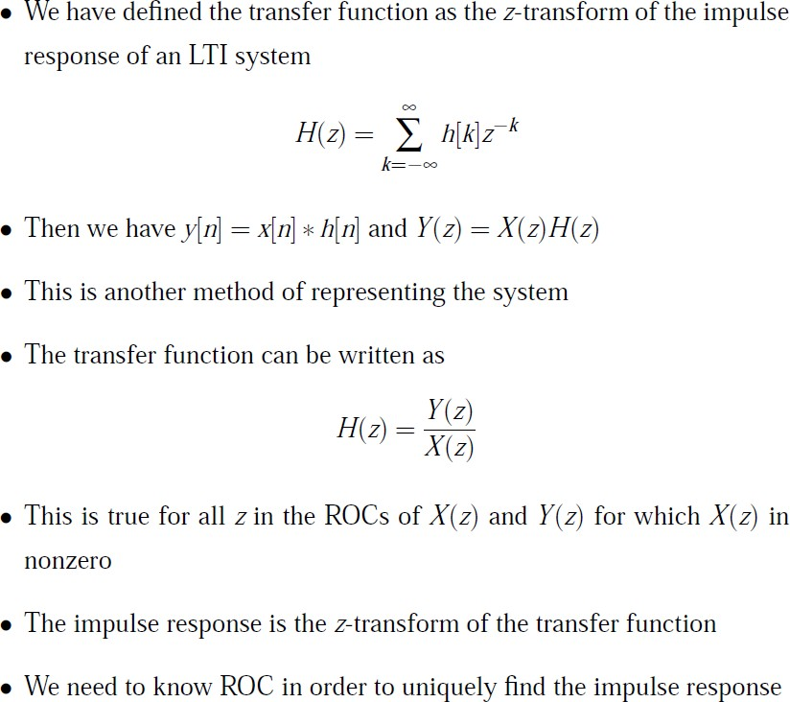

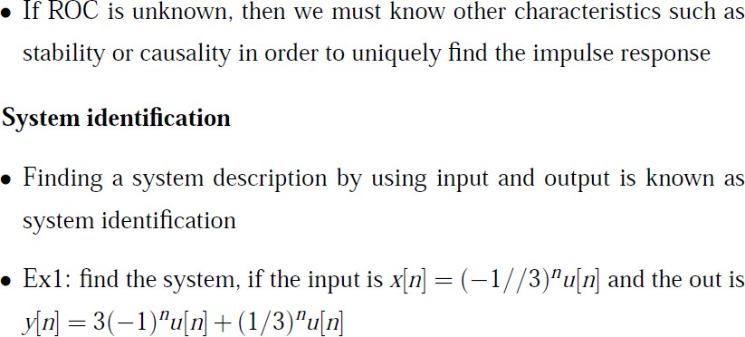

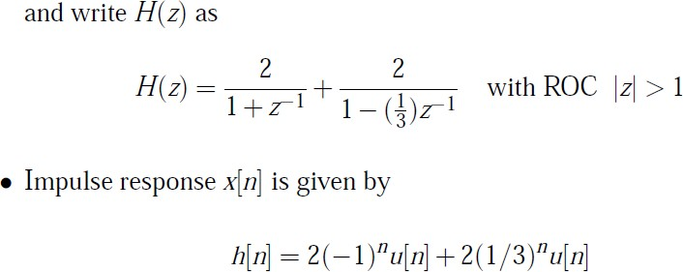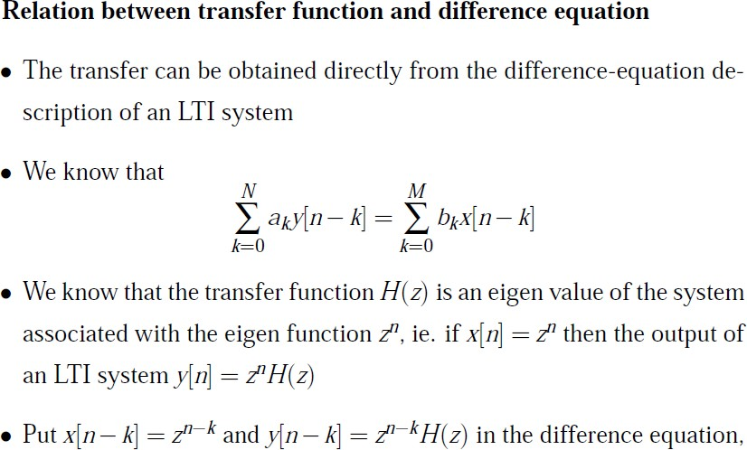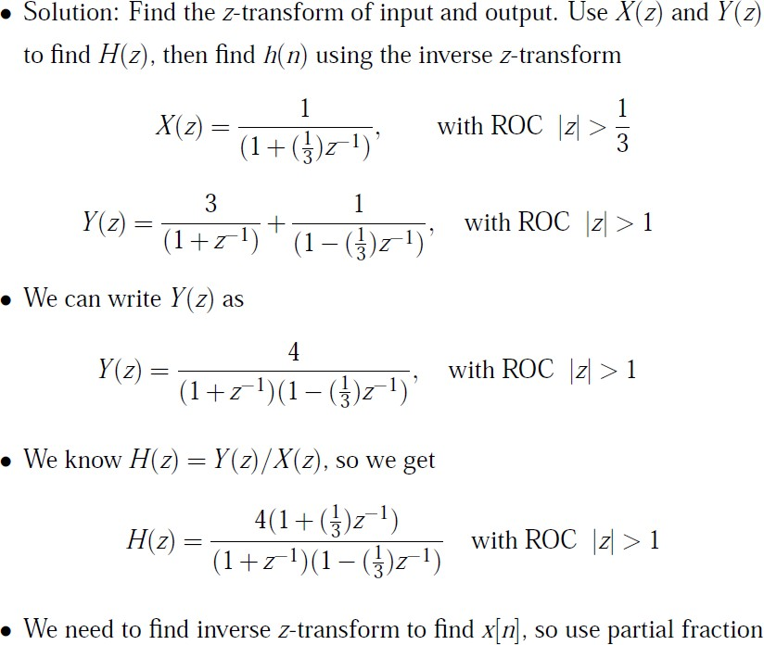

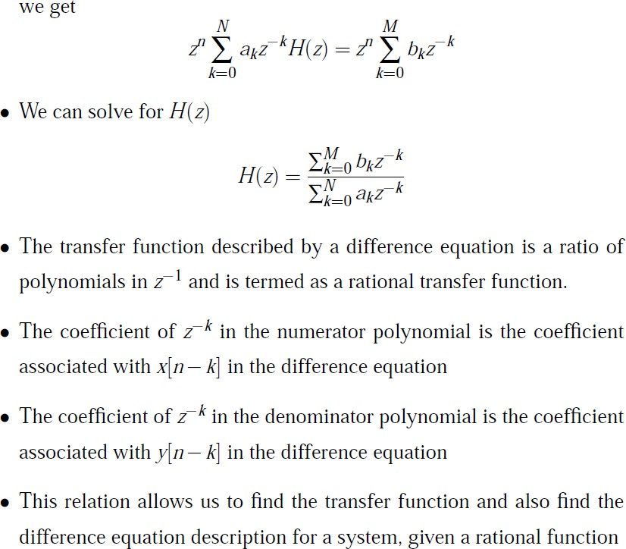

### Transfer function:

